UNITED STATES
SECURITIES AND EXCHANGE COMMISSION
Washington, D.C. 20549
FORM 8-K
CURRENT REPORT
PURSUANT TO SECTION 13 OR 15(d) OF
THE SECURITIES EXCHANGE ACT OF 1934
Date of report (Date of earliest event reported): May 5, 2026
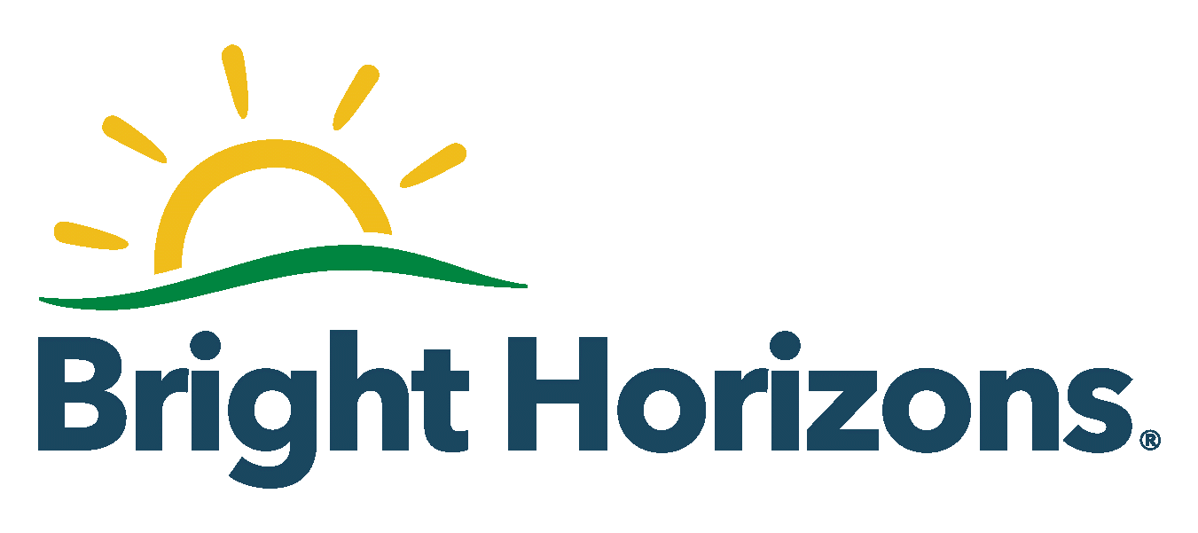
BRIGHT HORIZONS FAMILY SOLUTIONS INC.
(Exact name of registrant as specified in its charter)
Delaware |  |  |  |  |  | 001-35780 |  |  |  |  |  | 80-0188269
(State or other jurisdiction  of incorporation) |  |  |  |  |  | (Commission  File Number) |  |  |  |  |  | (I.R.S. Employer  Identification Number)
2 Wells Avenue
Newton, Massachusetts |  |  |  |  |  |  |  |  |  |  |  |  |  |  | 02459
(Address of principal executive offices) |  |  |  |  |  |  |  |  |  |  |  |  |  |  | (Zip code)
Registrant’s telephone number, including area code: (617) 673-8000
Not Applicable
(Former name or former address, if changed since last report)
Check the appropriate box below if the Form 8-K filing is intended to simultaneously satisfy the filing obligation of the registrant under any of the following provisions (see General Instruction A.2. below):
☐ |  |  | Written communications pursuant to Rule 425 under the Securities Act (17 CFR 230.425)
☐ |  |  | Soliciting material pursuant to Rule 14a-12 under the Exchange Act (17 CFR 240.14a-12)
☐ |  |  | Pre-commencement communications pursuant to Rule 14d-2(b) under the Exchange Act (17 CFR 240.14d-2(b))
☐ |  |  | Pre-commencement communications pursuant to Rule 13e-4(c) under the Exchange Act (17 CFR 240.13e-4(c))
Securities registered pursuant to Section 12(b) of the Act:
Title of each class |  |  |  |  |  | Trading Symbol(s) |  |  |  |  |  | Name of each exchange on which registered
Common Stock, $0.001 par value per share |  |  |  |  |  | BFAM |  |  |  |  |  | New York Stock Exchange
Indicate by check mark whether the registrant is an emerging growth company as defined in Rule 405 of the Securities Act of 1933 (§230.405 of this chapter) or Rule 12b-2 of the Securities Exchange Act of 1934 (§240.12b-2 of this chapter).
Emerging growth company ☐
If an emerging growth company, indicate by check mark if the registrant has elected not to use the extended transition period for complying with any new or revised financial accounting standards provided pursuant to Section 13(a) of the Exchange Act. ☐

Item 2.02 |  |  | Results of Operations and Financial Condition
On May 5, 2026, Bright Horizons Family Solutions Inc. issued a press release announcing its financial results for the fiscal quarter ended March 31, 2026 and reaffirmed financial guidance for the year 2026. A copy of the press release is furnished as Exhibit 99.1 hereto and is incorporated herein by reference.
Item 7.01 |  |  | Regulation FD Disclosure
On May 5, 2026, the Company posted an investor presentation to the Investor Relations section of its website at investors.brighthorizons.com. A copy of the investor presentation is furnished as Exhibit 99.2 hereto and is incorporated herein by reference.
The information contained in Items 2.02 and 7.01 of this Current Report on Form 8-K, including Exhibits 99.1 and 99.2 attached hereto, is being furnished and shall not be deemed “filed” for any purpose of Section 18 of the Securities Exchange Act of 1934, as amended, or otherwise subject to the liabilities of that Section, and shall not be deemed incorporated by reference in any filing under the Securities Act of 1933, as amended, regardless of any general incorporation language in any such filing.
Any website addresses included herein are inactive textual references only. The information contained on any such website referenced herein is not incorporated into this Current Report on Form 8-K. Important information may be disseminated initially or exclusively via the Company’s Investor Relations website; investors should consult the site to access this information.
Item 9.01 |  |  | Financial Statements and Exhibits
(d) Exhibits
99.1 |  |  |  |  |  | Press Release of Bright Horizons Family Solutions Inc. dated May 5, 2026.
99.2 |  |  |  |  |  | Investor Presentation of Bright Horizons Family Solutions Inc. dated May 5, 2026.
104 |  |  |  |  |  | Cover Page Interactive Data File (embedded within the Inline XBRL document).

SIGNATURES
Pursuant to the requirements of the Securities Exchange Act of 1934, the registrant has duly caused this report to be signed on its behalf by the undersigned thereunto duly authorized.
BRIGHT HORIZONS FAMILY SOLUTIONS INC.
Date: |  |  | May 5, 2026 |  |  | By: |  |  | /s/ Elizabeth Boland
 |  |  |  |  |  |  |  |  | Elizabeth Boland
 |  |  |  |  |  |  |  |  | Chief Financial Officer

Exhibit 99.1
Bright Horizons Family Solutions Reports Financial Results for the First Quarter of 2026
NEWTON, MA - (BUSINESS WIRE) - May 5, 2026 - Bright Horizons Family Solutions® Inc. (NYSE: BFAM) today announced financial results for the first quarter of 2026 and reaffirmed financial guidance for 2026 initially provided on February 12, 2026. Bright Horizons is a leading provider of high-quality early education and child care, comprehensive back-up care solutions, and educational advisory services. Our offerings support both working families and employers’ workforce strategies by supporting their employees across life and career stages, and improving employee recruitment, engagement, productivity, retention, and career advancement.
First Quarter 2026 Highlights (compared to First Quarter 2025):
•Revenue of $712 million (increase of 7%)
•Income from operations of $65 million (increase of 4%)
•Net income of $34 million and diluted earnings per common share of $0.62 (decreases of 10% and 6%, respectively)
Non-GAAP financial measures
•Adjusted EBITDA* of $96 million (increase of 4%)
•Adjusted income from operations* of $65 million (increase of 4%)
•Adjusted net income* of $45 million and diluted adjusted earnings per common share* of $0.82 (unchanged and increase of 6%, respectively)
“We are pleased with the solid start to 2026, with our first quarter results reflecting disciplined execution across the business,” said Stephen Kramer, Chief Executive Officer. “We generated 7% revenue growth, including 12% growth in Back-Up and 6% growth in Full-Service. This marks our sixteenth consecutive quarter of double-digit revenue growth in our Back-Up Care segment,” Kramer continued. “This sustained performance reflects both the scale of our Back-Up Care service delivery and the significant opportunity we see to continue to growth in this critically important service.”
First Quarter 2026 Results
Revenue increased by $46.7 million, or 7%, to $712.2 million in the first quarter of 2026 from the first quarter of 2025, primarily due to tuition increases at our centers and increased utilization of back-up care, as well as fluctuations in foreign currency exchange rates for our United Kingdom, Netherlands and Australia operations.
Income from operations was $64.9 million for the first quarter of 2026 compared to $62.3 million for the first quarter of 2025, an increase of 4%. The increase in income from operations is primarily related to operating leverage in our full service center-based child care and back-up care segments from increased service levels, partially offset by an increase in overhead support costs, including investments in technology. Net income was $34.1 million for the first quarter of 2026 compared to $38.0 million for the first quarter of 2025, a decrease of 10%, due to a higher effective tax rate and higher interest expense, partially offset by the increase in income from operations noted above. Diluted earnings per common share was $0.62 for the first quarter of 2026 compared to $0.66 for the first quarter of 2025.
In the first quarter of 2026, adjusted EBITDA* increased by $3.3 million, or 4%, to $95.6 million, and adjusted income from operations* increased by $2.7 million, or 4%, to $64.9 million from the first quarter of 2025, due to increased service levels and contributions from the full service center-based child care and back-up care segments, partially offset by an increase in overhead support costs. Adjusted net income* was $44.6 million, consistent with the same period in the prior year, as a result of the increase in adjusted income from operations offset by higher interest expense. Diluted adjusted earnings per common share* was $0.82 for the first quarter of 2026 compared to $0.77 for the first quarter of 2025.
As of March 31, 2026, the Company operated 988 early education and child care centers with the capacity to serve approximately 112,500 children and their families.
*Adjusted EBITDA, adjusted income from operations, adjusted net income and diluted adjusted earnings per common share are financial measures that are not calculated in accordance with generally accepted accounting principles in the United States (“GAAP”), which are commonly referred to as “non-GAAP financial measures.” Adjusted EBITDA represents EBITDA (which is net income, as determined in accordance with GAAP, before interest expense, income tax expense, depreciation, and amortization) adjusted to exclude stock-based compensation expense, and, at times, non-recurring costs, such as debt refinancing costs, lease termination costs, transaction costs and impairment costs. Adjusted income from operations represents income from operations, as determined in accordance with GAAP, adjusted to exclude, at times, non-recurring costs, such as debt refinancing costs, lease termination costs, transaction costs and impairment costs. Adjusted net income represents net income, as determined in accordance with GAAP, adjusted to exclude amortization, stock-based compensation expense, and, at times, non-recurring costs, such as debt refinancing costs, lease termination costs, transaction costs and impairment costs, and the income tax provision (benefit) thereon. Diluted adjusted earnings per common share is calculated using adjusted net income. These non-GAAP financial measures are more fully described and are reconciled from the respective measures determined under GAAP in “Presentation of Non-GAAP Financial Measures” and the attached table “Bright Horizons Family Solutions Inc. Non-GAAP Reconciliations,” respectively.
Balance Sheet and Liquidity
At March 31, 2026, the Company had $133.4 million of cash and cash equivalents and $250.2 million available for borrowing under our revolving credit facility. In the three months ended March 31, 2026, we generated $107.7 million of cash from operations, compared to $86.2 million for the same period in 2025, repurchased 2.9 million shares totaling $224.8 million compared to 0.2 million shares totaling $19.6 million for the same period in the prior year, and made net investments totaling $19.5 million, compared to $14.5 million for the same period in the prior year.
2026 Outlook
Based on current trends and expectations, we currently expect fiscal year 2026 revenue to be in the range of $3.075 billion to $3.125 billion and diluted adjusted earnings per common share to be in the range of $4.90 to $5.10. The Company will provide additional information on its outlook during its earnings conference call.
Conference Call
Bright Horizons Family Solutions will host an investor conference call today at 5:00 pm ET to discuss the results for the first quarter of 2026, as well as the Company’s updated business outlook and strategy. Interested parties are invited to listen to the conference call by dialing 1-844-539-3703, or for international callers, 1-412-652-1273, and asking for the Bright Horizons Family Solutions conference call moderated by Chief Executive Officer Stephen Kramer. Replays of the entire call will be available through May 19, 2026 at 1-844-512-2921, or for international callers, at 1-412-317-6671, conference ID #13758192. A link to the audio webcast of the conference call and a copy of this press release are also available through the Investor Relations section of the Company’s web site, investors.brighthorizons.com.
Forward-Looking Statements
This press release includes forward looking statements within the meaning of Section 27A of the Securities Act of 1933, as amended, and Section 21E of the Securities Exchange Act of 1934, as amended. The Company’s actual results may vary significantly from the results anticipated in these forward-looking statements, which can generally be identified by the use of forward-looking terminology, including the terms “believes,” “expects,” “may,” “will,” “should,” “seeks,” “projects,” “approximately,” “intends,” “plans,” “estimates” or “anticipates,” or, in each case, their negatives or other variations or comparable terminology. These forward-looking statements include all matters that are not historical facts, including statements regarding the Company’s intentions, beliefs or current expectations concerning, among other things, our results of operations, financial condition, liquidity, operating expectations, execution and delivery of our services and solutions, business trends, value of our service offerings, market penetration, our future growth opportunities, enrollment levels and trends in jurisdictions, margins, back-up care, our investments, long-term growth strategy, estimated effective tax rate, tax expense, our future business and financial performance, client partners and relationships, use and impact of our services, share repurchase activity and our 2026 financial guidance. By their nature, forward-looking statements involve risks and uncertainties because they relate to events and depend on circumstances that may or may not occur in the future. The Company believes that these risks and uncertainties include, but are not limited to, changes in the demand for child care, dependent care and other workplace solutions, including variations in enrollment trends and lower than expected demand from employer sponsor clients as well as variations in workforce demographics and work environments; the constrained labor market for teachers and staff and ability to hire and retain talent, including the impact of increased compensation and labor costs; the availability or lack of government support programs, and the impact of available government child care benefit programs; our ability to respond to changing client and customer needs; competition in our industry; the possibility that acquisitions may disrupt our operations and expose us to additional risk; our ability to pass on our increased costs; our indebtedness and the terms of such indebtedness; our ability to withstand seasonal fluctuations in the demand for our services; our ability to implement our growth strategies successfully; our ability to close underperforming centers; changes in general economic, political, business and financial market conditions and other macroeconomic events and uncertainty, including the impact of inflation and interest rate fluctuations; fluctuations in currency exchange rates; the effects of a cyber-attack, data breach or other security incident on our information technology system or software or those of our third party vendors; changes in tax rates or policies; damage or harm to our brand or reputation, including as a result of recent incidents and media coverage; outcome of litigation, legal matters and regulatory investigations; insurance risks; changes in laws and regulations; and other risks and uncertainties more fully described in the “Risk Factors” section of our Annual Report on Form 10-K filed on February 26, 2026, and other factors disclosed from time to time in our other filings with the Securities and Exchange Commission. These forward-looking statements speak only as of the time of this release and we do not undertake to publicly update or revise them, whether as a result of new information, future events or otherwise, except as required by law.
Presentation of Non-GAAP Financial Measures
In addition to the results provided in accordance with GAAP throughout this press release, the Company has provided certain non-GAAP financial measures that present operating results on a basis adjusted for certain items. The Company uses these non-GAAP financial measures as key performance indicators for the purpose of evaluating performance internally, and in connection with determining incentive compensation for Company management, including executive officers. Adjusted EBITDA is also used in connection with the determination of certain ratio requirements under our credit agreement. We believe that these non-GAAP financial measures provide investors with useful information with respect to our historical operations. These non-GAAP financial measures are not intended to replace, and should not be considered superior to, the presentation of our financial results in accordance with GAAP. The use of the terms adjusted EBITDA, adjusted income from operations, adjusted net income and diluted adjusted earnings per common share may differ from similar measures reported by other companies and may not be comparable to other similarly titled measures.
With respect to our outlook for diluted adjusted earnings per common share, we do not provide the most directly comparable GAAP financial measure or corresponding reconciliation to such GAAP financial measure on a forward-looking basis. We are unable to predict with reasonable certainty and without unreasonable effort certain items such as the timing and amount of net excess income tax benefits or shortfalls, future impairments, lease termination costs, transaction costs, and other non-recurring costs, as well as gains or losses from the early retirement of debt and the outcome from legal proceedings. These items are uncertain, depend on various factors outside our management’s control, and could significantly impact, either individually or in the aggregate, our future period earnings per common share as calculated and presented in accordance with GAAP.
For more information regarding adjusted EBITDA, adjusted income from operations, adjusted net income and diluted adjusted earnings per common share, refer to the reconciliation of GAAP financial measures to the non-GAAP financial measures in the attached table “Bright Horizons Family Solutions Inc. Non-GAAP Reconciliations.”
About Bright Horizons Family Solutions Inc.
Bright Horizons® is a leading provider of high-quality early education and child care, back-up care, and workforce education services. For 40 years, we have partnered with employers to support workforces by providing services that help working families and employees thrive personally and professionally. Bright Horizons operates approximately 1,000 early education and child care centers in the United States, the United Kingdom, the Netherlands, Australia and India, and serves more than 1,450 of the world’s leading employers. Bright Horizons’ early education and child care centers, back-up child and elder care, and workforce education programs help employees succeed at each life and career stage. For more information, go to www.brighthorizons.com.
Contacts:
Investors:
Elizabeth Boland
Chief Financial Officer - Bright Horizons
eboland@brighthorizons.com
617-673-8125
Michael Flanagan
Group Vice President - Strategic Finance - Bright Horizons
michael.flanagan@brighthorizons.com
617-673-8720
Jordan Bertier
Director - Investor Relations - Bright Horizons
jordan.bertier@brighthorizons.com
617-673-8192
Media:
Ilene Serpa
Vice President - Communications - Bright Horizons
iserpa@brighthorizons.com
617-673-8044

BRIGHT HORIZONS FAMILY SOLUTIONS INC.
CONDENSED CONSOLIDATED STATEMENTS OF INCOME
(In thousands, except share data)
(Unaudited)

 |  |  | Three Months Ended March 31,
 |  |  | 2026 |  |  |  |  |  | % |  |  |  |  |  | 2025 |  |  |  |  |  | %
Revenue |  |  | $ | 712,222 |  |  |  |  | 100.0 |  | % |  |  |  | $ | 665,527 |  |  |  |  | 100.0 |  | %
Cost of services |  |  | 548,732 |  |  |  |  |  | 77.0 |  | % |  |  |  | 509,790 |  |  |  |  |  | 76.6 |  | %
Gross profit |  |  | 163,490 |  |  |  |  |  | 23.0 |  | % |  |  |  | 155,737 |  |  |  |  |  | 23.4 |  | %
Selling, general and administrative expenses |  |  | 97,353 |  |  |  |  |  | 13.7 |  | % |  |  |  | 91,861 |  |  |  |  |  | 13.8 |  | %
Amortization of intangible assets |  |  | 1,188 |  |  |  |  |  | 0.2 |  | % |  |  |  | 1,604 |  |  |  |  |  | 0.2 |  | %
Income from operations |  |  | 64,949 |  |  |  |  |  | 9.1 |  | % |  |  |  | 62,272 |  |  |  |  |  | 9.4 |  | %
Interest expense — net |  |  | (12,022) |  |  |  |  |  | (1.7) |  | % |  |  |  | (10,351) |  |  |  |  |  | (1.6) |  | %
Income before income tax |  |  | 52,927 |  |  |  |  |  | 7.4 |  | % |  |  |  | 51,921 |  |  |  |  |  | 7.8 |  | %
Income tax expense |  |  | (18,819) |  |  |  |  |  | (2.6) |  | % |  |  |  | (13,872) |  |  |  |  |  | (2.1) |  | %
Net income |  |  | $ | 34,108 |  |  |  |  | 4.8 |  | % |  |  |  | $ | 38,049 |  |  |  |  | 5.7 |  | %
Earnings per common share:
Common stock — basic |  |  | $ | 0.63 |  |  |  |  |  |  |  |  |  |  | $ | 0.66
Common stock — diluted |  |  | $ | 0.62 |  |  |  |  |  |  |  |  |  |  | $ | 0.66
Weighted average common shares outstanding:
Common stock — basic |  |  | 54,337,976 |  |  |  |  |  |  |  |  |  |  |  | 57,383,787
Common stock — diluted |  |  | 54,704,178 |  |  |  |  |  |  |  |  |  |  |  | 57,950,748

BRIGHT HORIZONS FAMILY SOLUTIONS INC.
CONDENSED CONSOLIDATED BALANCE SHEETS
(In thousands)
(Unaudited)

 |  |  | March 31, 2026 |  |  |  |  |  | December 31, 2025
ASSETS
Current assets:
Cash and cash equivalents |  |  | $ | 133,448 |  |  |  |  | $ | 140,091
Accounts receivable — net |  |  | 215,726 |  |  |  |  |  | 293,983
Prepaid expenses and other current assets |  |  | 80,574 |  |  |  |  |  | 69,899
Total current assets |  |  | 429,748 |  |  |  |  |  | 503,973
Fixed assets — net |  |  | 566,675 |  |  |  |  |  | 574,200
Goodwill |  |  | 1,824,458 |  |  |  |  |  | 1,824,175
Other intangible assets — net |  |  | 192,439 |  |  |  |  |  | 193,452
Operating lease right-of-use assets |  |  | 664,638 |  |  |  |  |  | 682,069
Other assets |  |  | 113,782 |  |  |  |  |  | 111,734
Total assets |  |  | $ | 3,791,740 |  |  |  |  | $ | 3,889,603
LIABILITIES AND STOCKHOLDERS’ EQUITY
Current liabilities:
Current portion of revolving credit facility |  |  | $ | 185,560 |  |  |  |  | $ | 199,552
Accounts payable and accrued expenses |  |  | 266,763 |  |  |  |  |  | 292,812
Current portion of operating lease liabilities |  |  | 110,520 |  |  |  |  |  | 110,229
Deferred revenue |  |  | 319,814 |  |  |  |  |  | 330,647
Other current liabilities |  |  | 45,111 |  |  |  |  |  | 32,925
Total current liabilities |  |  | 927,768 |  |  |  |  |  | 966,165
Long-term debt — net |  |  | 897,704 |  |  |  |  |  | 747,614
Operating lease liabilities |  |  | 679,571 |  |  |  |  |  | 702,845
Other long-term liabilities |  |  | 119,780 |  |  |  |  |  | 118,815
Deferred income taxes |  |  | 21,287 |  |  |  |  |  | 14,873
Total liabilities |  |  | 2,646,110 |  |  |  |  |  | 2,550,312
Total stockholders’ equity |  |  | 1,145,630 |  |  |  |  |  | 1,339,291
Total liabilities and stockholders’ equity |  |  | $ | 3,791,740 |  |  |  |  | $ | 3,889,603

BRIGHT HORIZONS FAMILY SOLUTIONS INC.
CONDENSED CONSOLIDATED STATEMENTS OF CASH FLOWS
(In thousands)
(Unaudited)

 |  |  | Three Months Ended March 31,
 |  |  | 2026 |  |  |  |  |  | 2025
CASH FLOWS FROM OPERATING ACTIVITIES:
Net income |  |  | $ | 34,108 |  |  |  |  | $ | 38,049
Adjustments to reconcile net income to net cash provided by operating activities:
Depreciation and amortization |  |  | 23,233 |  |  |  |  |  | 21,875
Stock-based compensation expense |  |  | 7,424 |  |  |  |  |  | 8,157
Deferred income taxes |  |  | 5,855 |  |  |  |  |  | 5,012
Non-cash interest and other — net |  |  | 2,355 |  |  |  |  |  | (113)
Changes in assets and liabilities |  |  | 34,746 |  |  |  |  |  | 13,198
Net cash provided by operating activities |  |  | 107,721 |  |  |  |  |  | 86,178
CASH FLOWS FROM INVESTING ACTIVITIES:
Purchases of fixed assets — net |  |  | (20,121) |  |  |  |  |  | (15,231)
Proceeds from debt securities and other investments |  |  | 5,085 |  |  |  |  |  | 4,874
Purchases of debt securities and other investments |  |  | (4,476) |  |  |  |  |  | (4,185)
Net cash used in investing activities |  |  | (19,512) |  |  |  |  |  | (14,542)
CASH FLOWS FROM FINANCING ACTIVITIES:
Revolving credit facility — net |  |  | 138,404 |  |  |  |  |  | —
Principal payments of long-term debt |  |  | — |  |  |  |  |  | (49,500)
Purchase of treasury stock |  |  | (224,796) |  |  |  |  |  | (19,573)
Taxes paid related to the net share settlement of stock options and restricted stock |  |  | (6,926) |  |  |  |  |  | (12,587)
Proceeds from issuance of common stock upon exercise of options |  |  | — |  |  |  |  |  | 8,251
Net cash used in financing activities |  |  | (93,318) |  |  |  |  |  | (73,409)
Effect of exchange rates on cash, cash equivalents and restricted cash |  |  | (1,317) |  |  |  |  |  | 2,026
Net increase (decrease) in cash, cash equivalents and restricted cash |  |  | (6,426) |  |  |  |  |  | 253
Cash, cash equivalents and restricted cash — beginning of period |  |  | 143,158 |  |  |  |  |  | 123,715
Cash, cash equivalents and restricted cash — end of period |  |  | $ | 136,732 |  |  |  |  | $ | 123,968

BRIGHT HORIZONS FAMILY SOLUTIONS INC.
SEGMENT INFORMATION
(In thousands)
(Unaudited)

 |  |  | Full service  center-based  child care |  |  |  |  |  | Back-up care |  |  |  |  |  | Educational  advisory services |  |  |  |  |  | Total
Three Months Ended March 31, 2026
Revenue |  |  | $ | 540,634 |  |  |  |  | $ | 144,669 |  |  |  |  | $ | 26,919 |  |  |  |  | $ | 712,222
Income from operations |  |  | 36,905 |  |  |  |  |  | 25,572 |  |  |  |  |  | 2,472 |  |  |  |  |  | 64,949
Adjusted income from operations |  |  | 36,905 |  |  |  |  |  | 25,572 |  |  |  |  |  | 2,472 |  |  |  |  |  | 64,949
As a percentage of revenue |  |  | 7 |  | % |  |  |  | 18 |  | % |  |  |  | 9 |  | % |  |  |  | 9 |  | %
Three Months Ended March 31, 2025
Revenue |  |  | $ | 510,547 |  |  |  |  | $ | 128,612 |  |  |  |  | $ | 26,368 |  |  |  |  | $ | 665,527
Income from operations |  |  | 33,254 |  |  |  |  |  | 26,384 |  |  |  |  |  | 2,634 |  |  |  |  |  | 62,272
Adjusted income from operations |  |  | 33,254 |  |  |  |  |  | 26,384 |  |  |  |  |  | 2,634 |  |  |  |  |  | 62,272
As a percentage of revenue |  |  | 7 |  | % |  |  |  | 21 |  | % |  |  |  | 10 |  | % |  |  |  | 9 |  | %

BRIGHT HORIZONS FAMILY SOLUTIONS INC.
NON-GAAP RECONCILIATIONS
(In thousands, except share data)
(Unaudited)

 |  |  | Three Months Ended March 31,
 |  |  | 2026 |  |  |  |  |  | 2025
Net income |  |  | $ | 34,108 |  |  |  |  | $ | 38,049
Interest expense — net |  |  | 12,022 |  |  |  |  |  | 10,351
Income tax expense |  |  | 18,819 |  |  |  |  |  | 13,872
Depreciation |  |  | 22,045 |  |  |  |  |  | 20,271
Amortization of intangible assets |  |  | 1,188 |  |  |  |  |  | 1,604
EBITDA |  |  | 88,182 |  |  |  |  |  | 84,147
As a percentage of revenue |  |  | 12% |  |  |  |  |  | 13%
Additional adjustments:
Stock-based compensation expense (a) |  |  | 7,424 |  |  |  |  |  | 8,157
Total adjustments |  |  | 7,424 |  |  |  |  |  | 8,157
Adjusted EBITDA |  |  | $ | 95,606 |  |  |  |  | $ | 92,304
As a percentage of revenue |  |  | 13 |  | % |  |  |  | 14 |  | %
Income from operations |  |  | $ | 64,949 |  |  |  |  | $ | 62,272
Adjusted income from operations |  |  | $ | 64,949 |  |  |  |  | $ | 62,272
As a percentage of revenue |  |  | 9 |  | % |  |  |  | 9 |  | %
Net income |  |  | $ | 34,108 |  |  |  |  | $ | 38,049
Income tax expense |  |  | 18,819 |  |  |  |  |  | 13,872
Income before income tax |  |  | 52,927 |  |  |  |  |  | 51,921
Stock-based compensation expense (a) |  |  | 7,424 |  |  |  |  |  | 8,157
Amortization of intangible assets |  |  | 1,188 |  |  |  |  |  | 1,604
Adjusted income before income tax |  |  | 61,539 |  |  |  |  |  | 61,682
Adjusted income tax expense (b) |  |  | (16,923) |  |  |  |  |  | (16,963)
Adjusted net income |  |  | $ | 44,616 |  |  |  |  | $ | 44,719
As a percentage of revenue |  |  | 6 |  | % |  |  |  | 7 |  | %
Weighted average common shares outstanding — diluted |  |  | 54,704,178 |  |  |  |  |  | 57,950,748
Diluted adjusted earnings per common share |  |  | $ | 0.82 |  |  |  |  | $ | 0.77

(a)Stock-based compensation expense represents non-cash stock-based compensation expense in accordance with Accounting Standards Codification Topic 718, Compensation-Stock Compensation.
(b)Adjusted income tax expense represents income tax expense calculated on adjusted income before income tax at an effective tax rate of approximately 28% for the three months ended March 31, 2026 and 2025. The jurisdictional mix of the expected adjusted income before income tax for the full year will affect the estimated effective tax rate for the year.
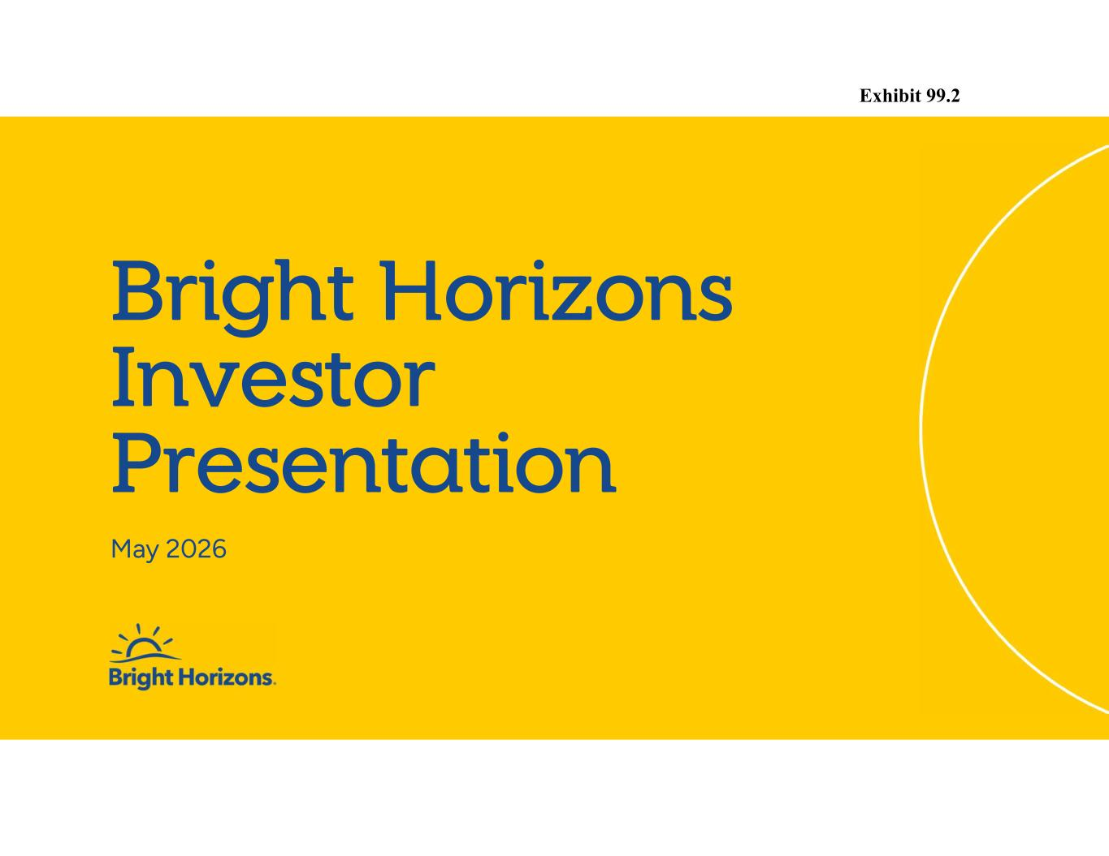

Bright Horizons Investor Presentation May 2026 Exhibit 99.2

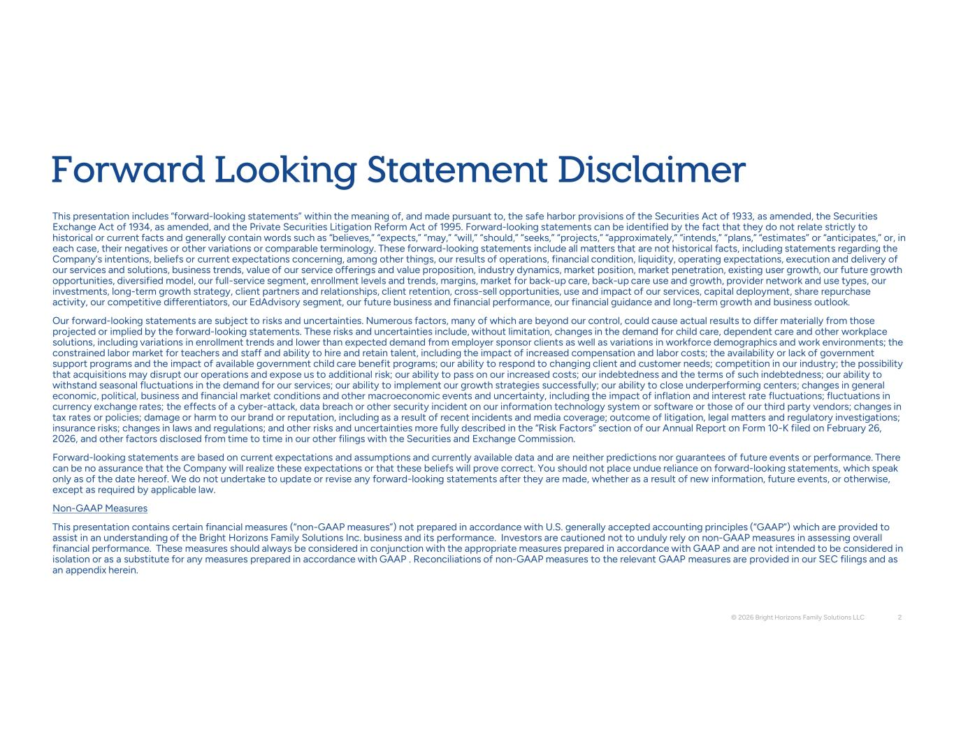
Forward Looking Statement Disclaimer This presentation includes “forward-looking statements” within the meaning of, and made pursuant to, the safe harbor provisions of the Securities Act of 1933, as amended, the Securities Exchange Act of 1934, as amended, and the Private Securities Litigation Reform Act of 1995. Forward-looking statements can be identified by the fact that they do not relate strictly to historical or current facts and generally contain words such as “believes,” “expects,” “may,” “will,” “should,” “seeks,” “projects,” “approximately,” “intends,” “plans,” “estimates” or “anticipates,” or, in each case, their negatives or other variations or comparable terminology. These forward-looking statements include all matters that are not historical facts, including statements regarding the Company’s intentions, beliefs or current expectations concerning, among other things, our results of operations, financial condition, liquidity, operating expectations, execution and delivery of our services and solutions, business trends, value of our service offerings and value proposition, industry dynamics, market position, market penetration, existing user growth, our future growth opportunities, diversified model, our full-service segment, enrollment levels and trends, margins, market for back-up care, back-up care use and growth, provider network and use types, our investments, long-term growth strategy, client partners and relationships, client retention, cross-sell opportunities, use and impact of our services, capital deployment, share repurchase activity, our competitive differentiators, our EdAdvisory segment, our future business and financial performance, our financial guidance and long-term growth and business outlook. Our forward-looking statements are subject to risks and uncertainties. Numerous factors, many of which are beyond our control, could cause actual results to differ materially from those projected or implied by the forward-looking statements. These risks and uncertainties include, without limitation, changes in the demand for child care, dependent care and other workplace solutions, including variations in enrollment trends and lower than expected demand from employer sponsor clients as well as variations in workforce demographics and work environments; the constrained labor market for teachers and staff and ability to hire and retain talent, including the impact of increased compensation and labor costs; the availability or lack of government support programs and the impact of available government child care benefit programs; our ability to respond to changing client and customer needs; competition in our industry; the possibility that acquisitions may disrupt our operations and expose us to additional risk; our ability to pass on our increased costs; our indebtedness and the terms of such indebtedness; our ability to withstand seasonal fluctuations in the demand for our services; our ability to implement our growth strategies successfully; our ability to close underperforming centers; changes in general economic, political, business and financial market conditions and other macroeconomic events and uncertainty, including the impact of inflation and interest rate fluctuations; fluctuations in currency exchange rates; the effects of a cyber-attack, data breach or other security incident on our information technology system or software or those of our third party vendors; changes in tax rates or policies; damage or harm to our brand or reputation, including as a result of recent incidents and media coverage; outcome of litigation, legal matters and regulatory investigations; insurance risks; changes in laws and regulations; and other risks and uncertainties more fully described in the “Risk Factors” section of our Annual Report on Form 10-K filed on February 26, 2026, and other factors disclosed from time to time in our other filings with the Securities and Exchange Commission. Forward-looking statements are based on current expectations and assumptions and currently available data and are neither predictions nor guarantees of future events or performance. There can be no assurance that the Company will realize these expectations or that these beliefs will prove correct. You should not place undue reliance on forward-looking statements, which speak only as of the date hereof. We do not undertake to update or revise any forward-looking statements after they are made, whether as a result of new information, future events, or otherwise, except as required by applicable law. Non-GAAP Measures This presentation contains certain financial measures (“non-GAAP measures”) not prepared in accordance with U.S. generally accepted accounting principles (“GAAP”) which are provided to assist in an understanding of the Bright Horizons Family Solutions Inc. business and its performance. Investors are cautioned not to unduly rely on non-GAAP measures in assessing overall financial performance. These measures should always be considered in conjunction with the appropriate measures prepared in accordance with GAAP and are not intended to be considered in isolation or as a substitute for any measures prepared in accordance with GAAP . Reconciliations of non-GAAP measures to the relevant GAAP measures are provided in our SEC filings and as an appendix herein. © 2026 Bright Horizons Family Solutions LLC 2

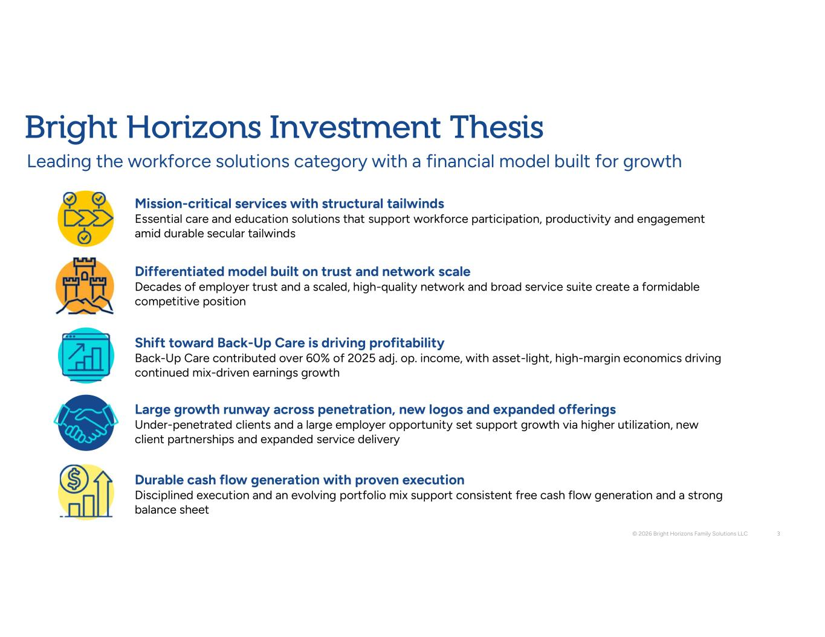
Shift toward Back-Up Care is driving profitability Back-Up Care contributed over 60% of 2025 adj. op. income, with asset-light, high-margin economics driving continued mix-driven earnings growth Large growth runway across penetration, new logos and expanded offerings Under-penetrated clients and a large employer opportunity set support growth via higher utilization, new client partnerships and expanded service delivery Durable cash flow generation with proven execution Disciplined execution and an evolving portfolio mix support consistent free cash flow generation and a strong balance sheet Bright Horizons Investment Thesis Leading the workforce solutions category with a financial model built for growth © 2026 Bright Horizons Family Solutions LLC 3 Mission-critical services with structural tailwinds Essential care and education solutions that support workforce participation, productivity and engagement amid durable secular tailwinds Differentiated model built on trust and network scale Decades of employer trust and a scaled, high-quality network and broad service suite create a formidable competitive position

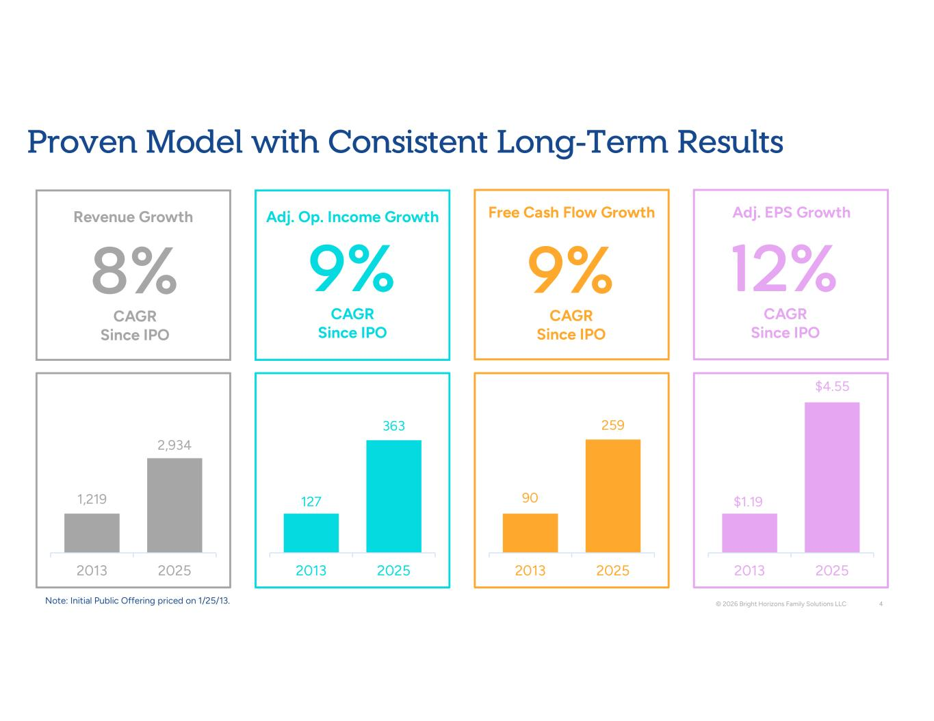
Revenue Growth 8% CAGR Since IPO Adj. Op. Income Growth 9% CAGR Since IPO Free Cash Flow Growth 9% CAGR Since IPO Adj. EPS Growth 12% CAGR Since IPO Proven Model with Consistent Long-Term Results © 2026 Bright Horizons Family Solutions LLC 4 1,219 2,934 2013 2025 127 363 2013 2025 90 259 2013 2025 $1.19 $4.55 2013 2025 Note: Initial Public Offering priced on 1/25/13.

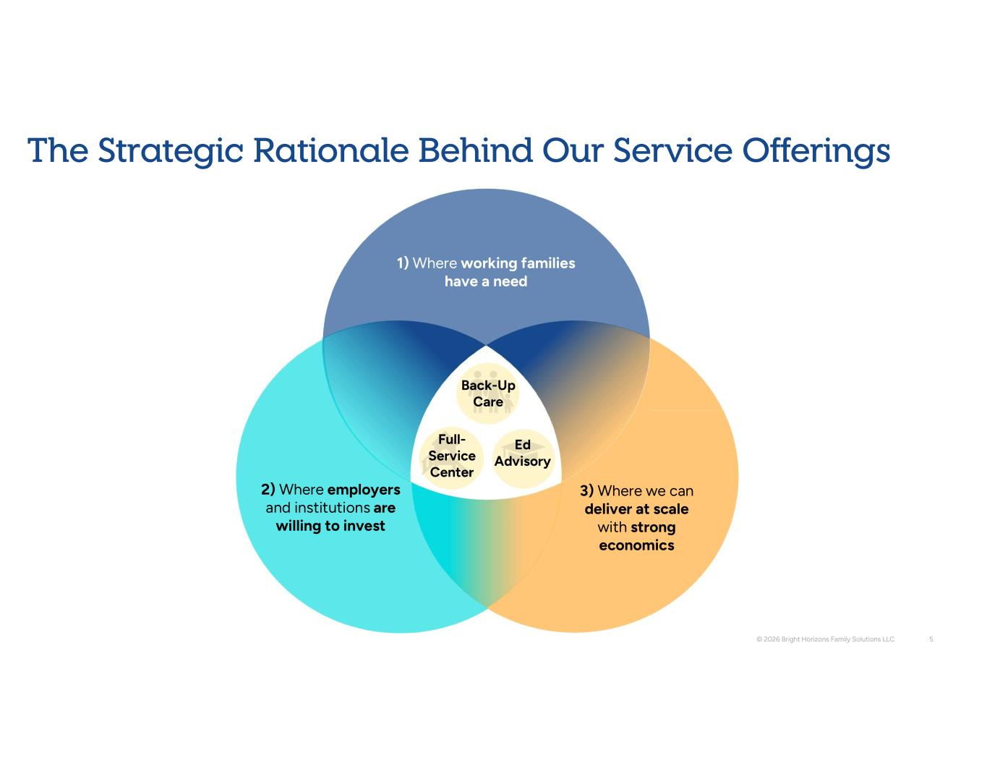
The Strategic Rationale Behind Our Service Offerings © 2026 Bright Horizons Family Solutions LLC 5 1) Where working families have a need 2) Where employers and institutions are willing to invest 3) Where we can deliver at scale with strong economics Back-Up Care Full- Service Center Ed Advisory

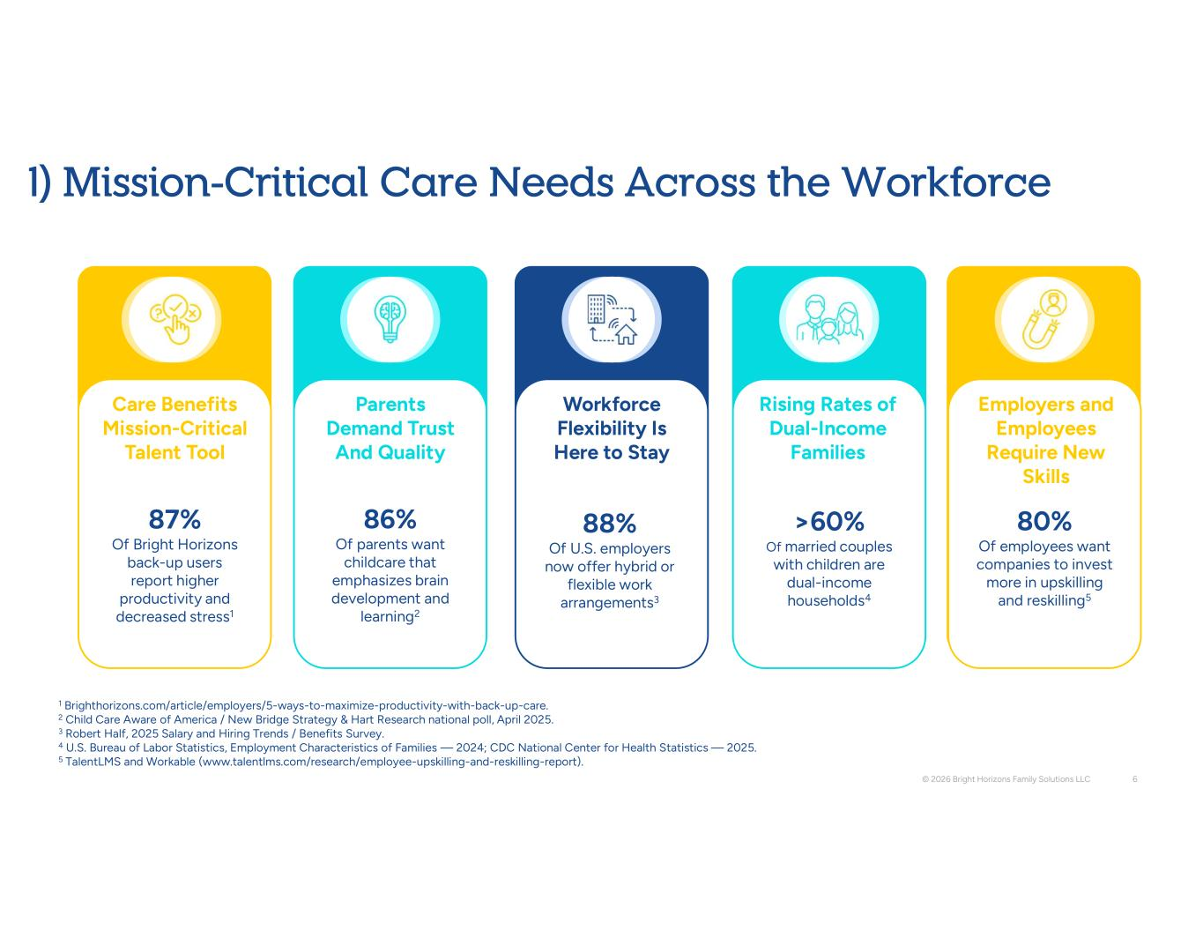
87% Of Bright Horizons back-up users report higher productivity and decreased stress1 Workforce Flexibility Is Here to Stay Care Benefits Mission-Critical Talent Tool 1 Brighthorizons.com/article/employers/5-ways-to-maximize-productivity-with-back-up-care. 2 Child Care Aware of America / New Bridge Strategy & Hart Research national poll, April 2025. 3 Robert Half, 2025 Salary and Hiring Trends / Benefits Survey. 4 U.S. Bureau of Labor Statistics, Employment Characteristics of Families — 2024; CDC National Center for Health Statistics — 2025. 5 TalentLMS and Workable (www.talentlms.com/research/employee-upskilling-and-reskilling-report). © 2026 Bright Horizons Family Solutions LLC 6 Rising Rates of Dual-Income Families 86% Of parents want childcare that emphasizes brain development and learning2 Parents Demand Trust And Quality 88% Of U.S. employers now offer hybrid or flexible work arrangements3 Employers and Employees Require New Skills 80% Of employees want companies to invest more in upskilling and reskilling5 >60% Of married couples with children are dual-income households4 1) Mission-Critical Care Needs Across the Workforce

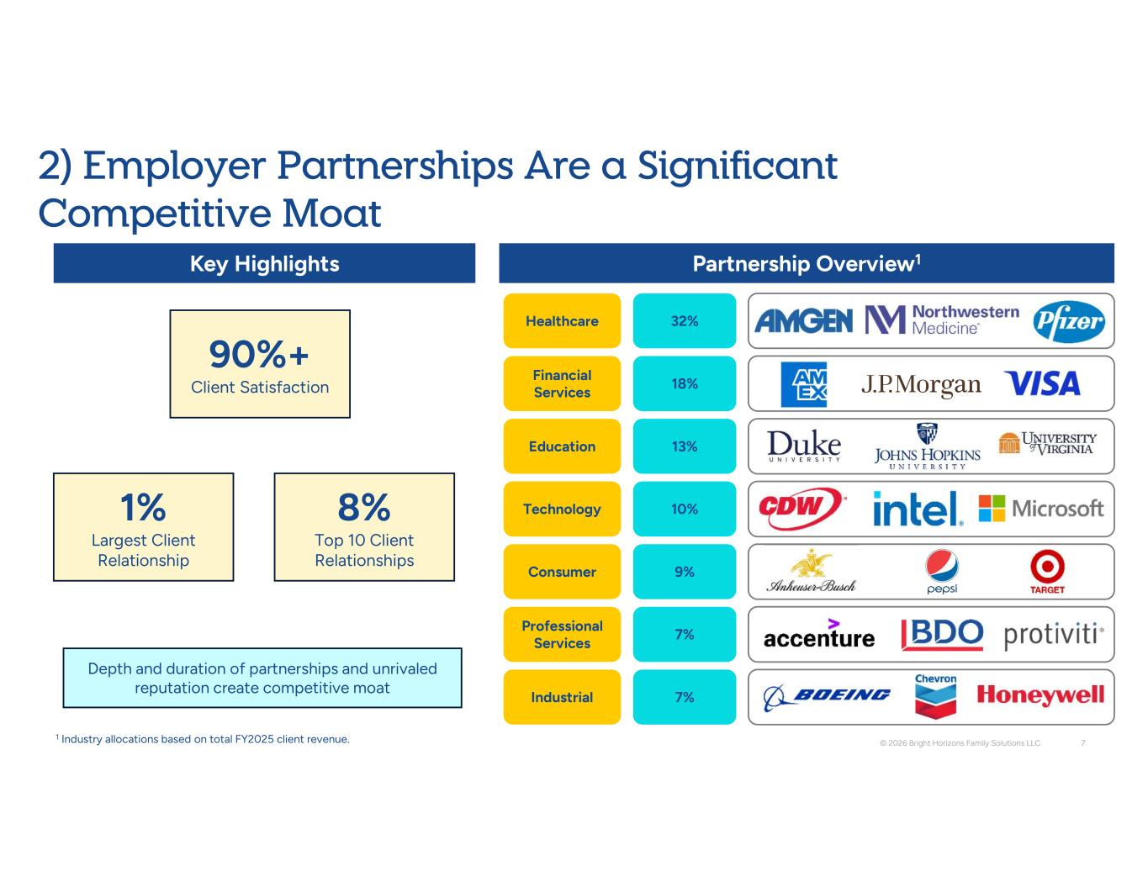
Healthcare 32% Financial Services 18% Education 13% Consumer 9% Professional Services 7% Technology 10% Industrial 7% © 2026 Bright Horizons Family Solutions LLC 7 90%+ Client Satisfaction 8% Top 10 Client Relationships 1% Largest Client Relationship Key Highlights Partnership Overview1 Depth and duration of partnerships and unrivaled reputation create competitive moat 1 Industry allocations based on total FY2025 client revenue. 2) Employer Partnerships Are a Significant Competitive Moat

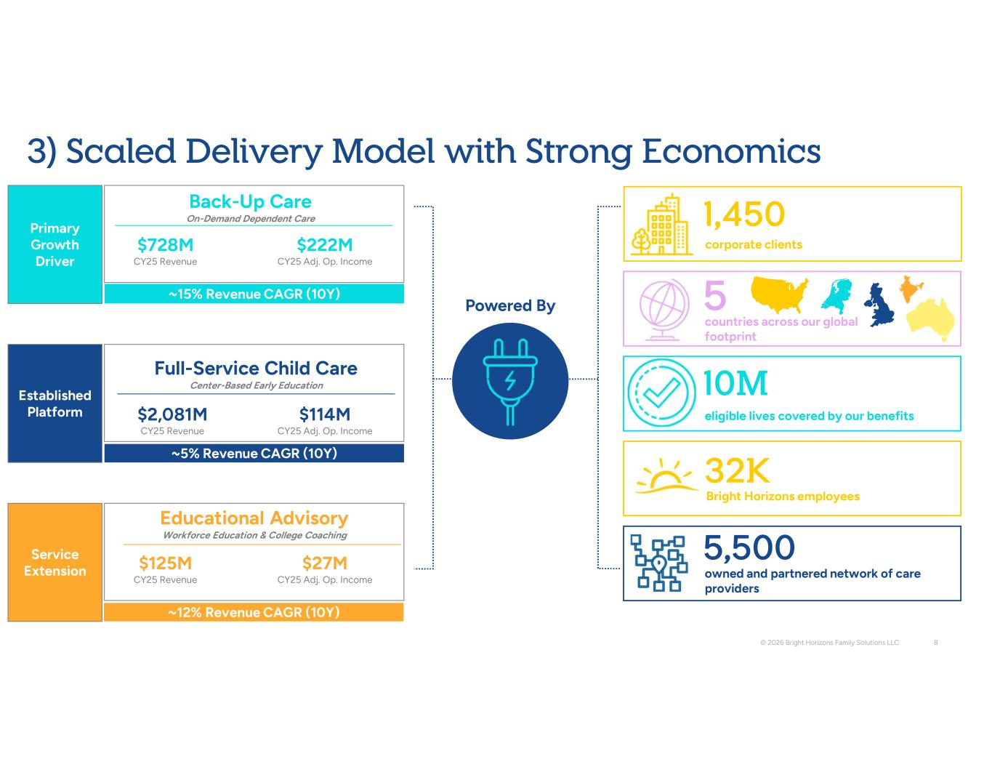
2,081M CY25 Revenue 114M CY25 Adj. Op. Income Primary Growth Driver Back-Up Care On-Demand Dependent Care ~15% Revenue CAGR (10Y) 728M CY25 Revenue 222M CY25 Adj. Op. Income 125M CY25 Revenue 27M CY25 Adj. Op. Income © 2026 Bright Horizons Family Solutions LLC 8 Established Platform Full-Service Child Care Center-Based Early Education ~5% Revenue CAGR (10Y) Service Extension Educational Advisory Workforce Education & College Coaching ~12% Revenue CAGR (10Y) corporate clients 1,450 10M eligible lives covered by our benefits 5 countries across our global footprint Bright Horizons employees 32K owned and partnered network of care providers 5,500 Powered By 3) Scaled Delivery Model with Strong Economics

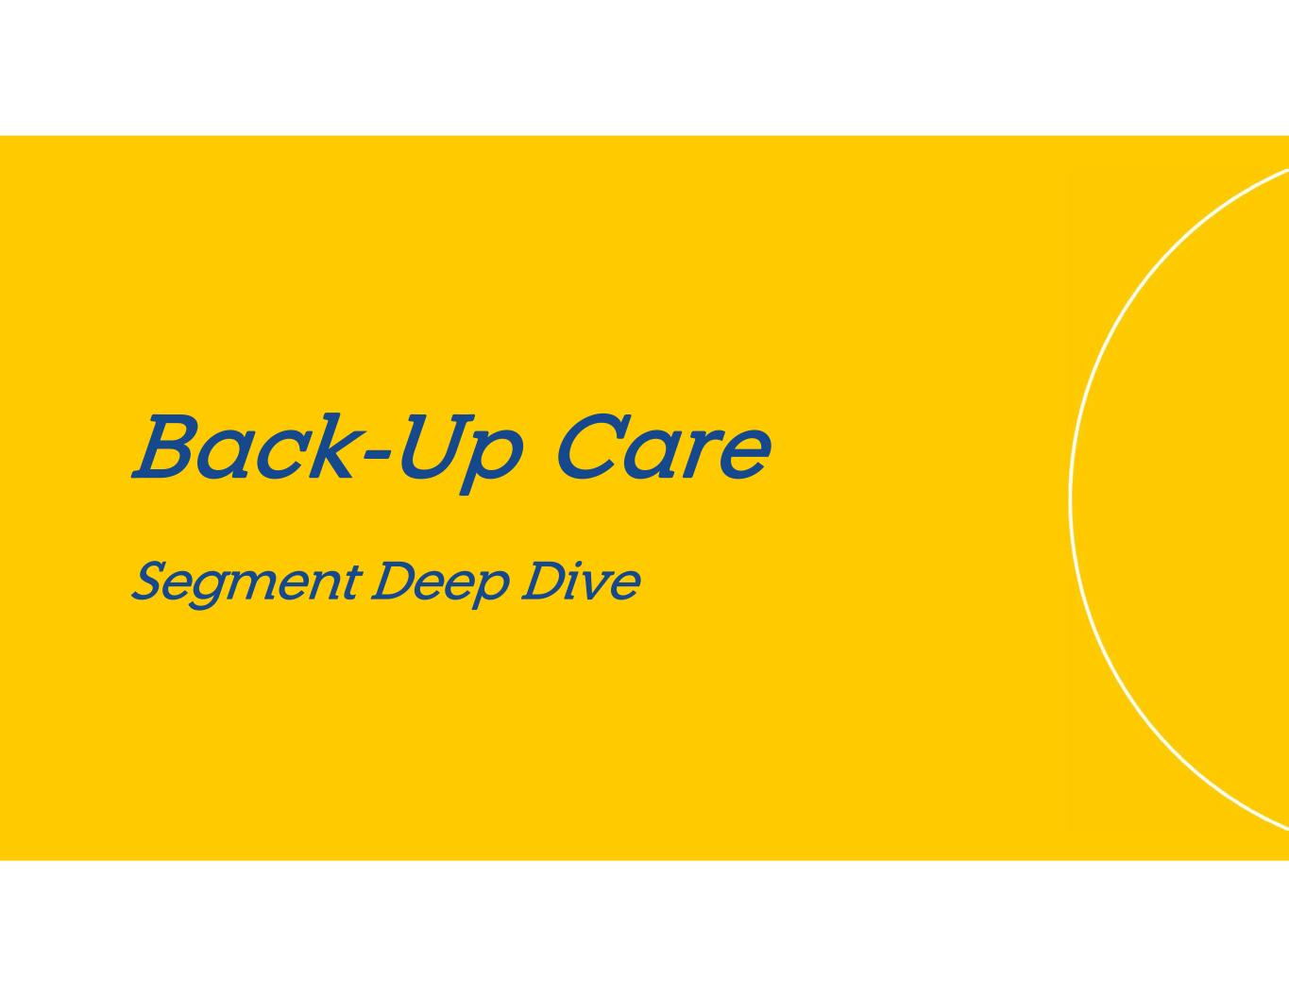
Back-Up Care Segment Deep Dive

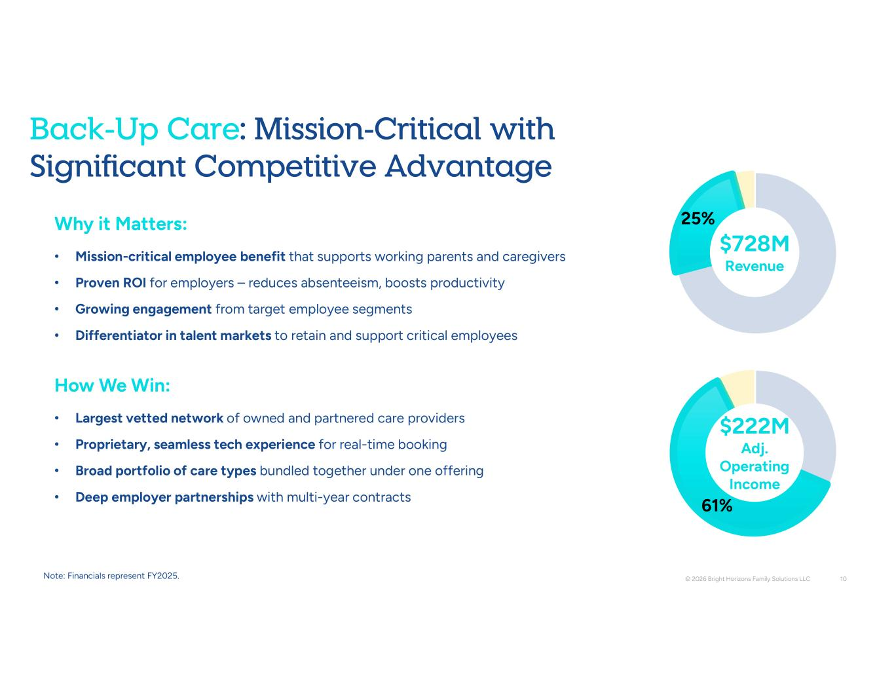
Why it Matters: • Mission-critical employee benefit that supports working parents and caregivers • Proven ROI for employers – reduces absenteeism, boosts productivity • Growing engagement from target employee segments • Differentiator in talent markets to retain and support critical employees How We Win: • Largest vetted network of owned and partnered care providers • Proprietary, seamless tech experience for real-time booking • Broad portfolio of care types bundled together under one offering • Deep employer partnerships with multi-year contracts 25% 61% © 2026 Bright Horizons Family Solutions LLC 10 Back-Up Care: Mission-Critical with Significant Competitive Advantage 728M Revenue 222M Adj. Operating Income Note: Financials represent FY2025.

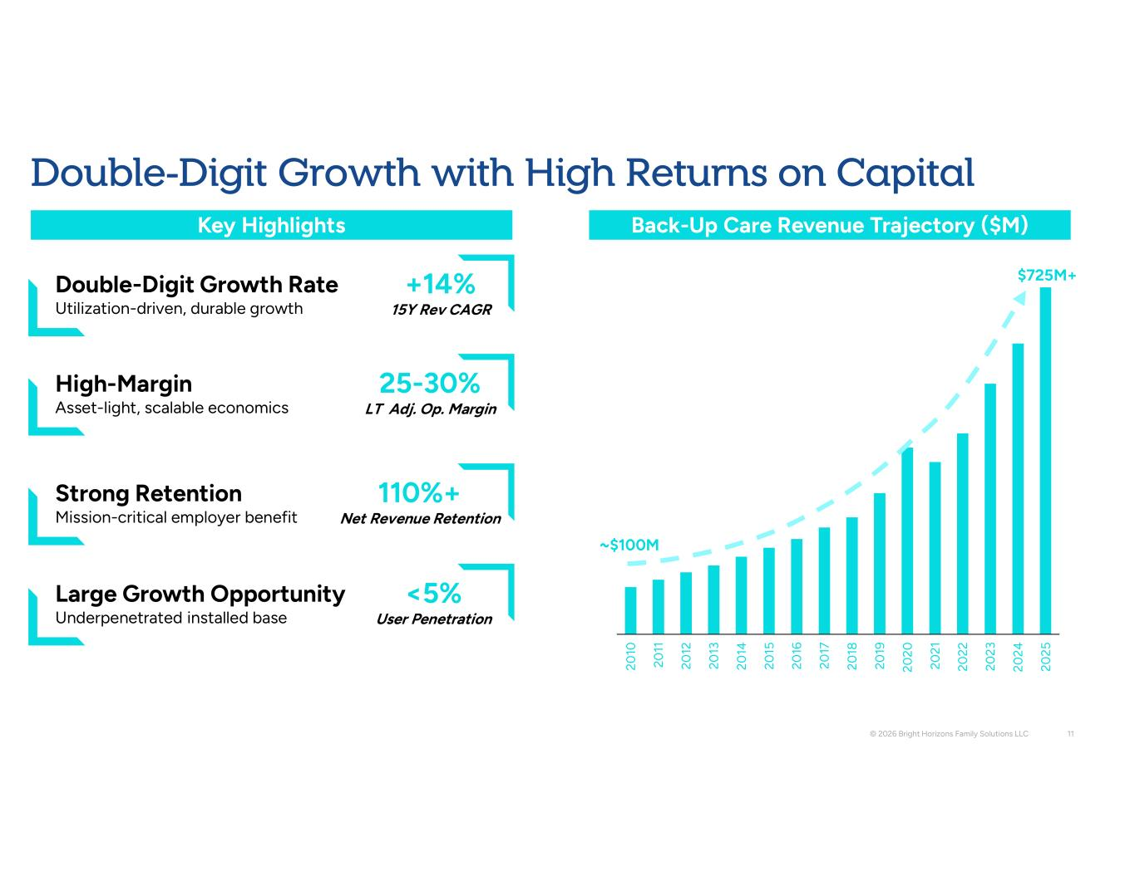
20 10 20 11 20 12 20 13 20 14 20 15 20 16 20 17 20 18 20 19 20 20 20 21 20 22 20 23 20 24 20 25 725M+ ~ 100M © 2026 Bright Horizons Family Solutions LLC 11 Back-Up Care Revenue Trajectory ( M) Key Highlights Double-Digit Growth Rate Utilization-driven, durable growth +14% 15Y Rev CAGR High-Margin Asset-light, scalable economics 25-30% LT Adj. Op. Margin Strong Retention Mission-critical employer benefit 110%+ Net Revenue Retention Large Growth Opportunity Underpenetrated installed base <5% User Penetration Double-Digit Growth with High Returns on Capital

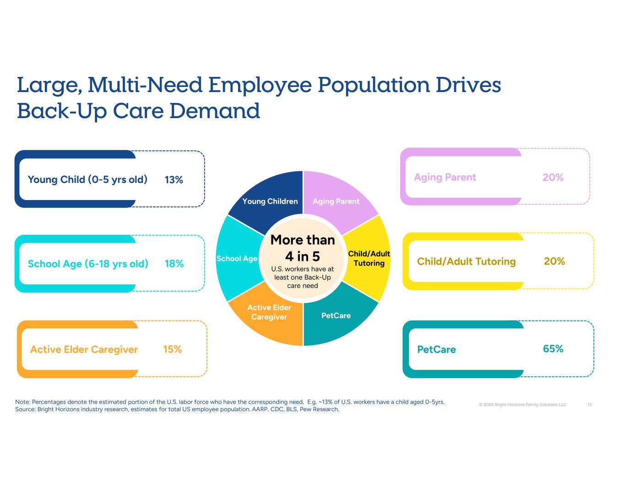
Aging Parent Child/Adult Tutoring PetCare Active Elder Caregiver School Age Young Children Young Child (0-5 yrs old) © 2026 Bright Horizons Family Solutions LLC 12 Large, Multi-Need Employee Population Drives Back-Up Care Demand 13% More than 4 in 5 U.S. workers have at least one Back-Up care need School Age (6-18 yrs old) 18% Active Elder Caregiver 15% Aging Parent 20% Child/Adult Tutoring 20% PetCare 65% Note: Percentages denote the estimated portion of the U.S. labor force who have the corresponding need. E.g. ~13% of U.S. workers have a child aged 0-5yrs. Source: Bright Horizons industry research, estimates for total US employee population. AARP, CDC, BLS, Pew Research.

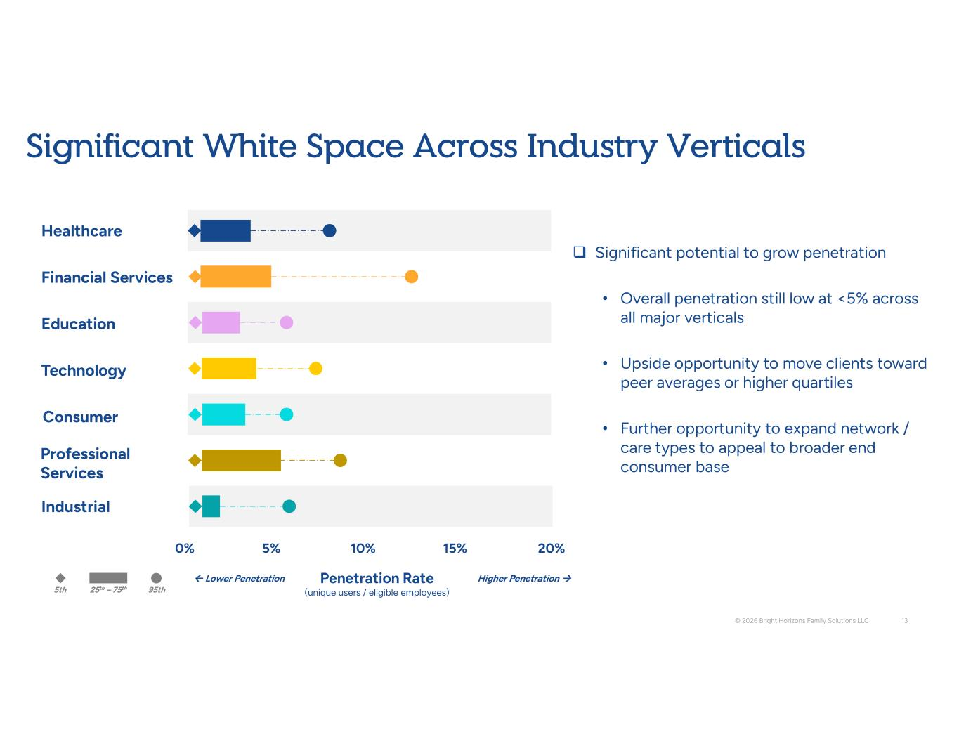
Healthcare Financial Services Education Technology Consumer Professional Services Industrial 0% 10% 20% 15% 5% Penetration Rate (unique users / eligible employees) ← Lower Penetration Higher Penetration → 5th 95th 25th – 75th © 2026 Bright Horizons Family Solutions LLC 13 Significant White Space Across Industry Verticals  Significant potential to grow penetration • Overall penetration still low at <5% across all major verticals • Upside opportunity to move clients toward peer averages or higher quartiles • Further opportunity to expand network / care types to appeal to broader end consumer base

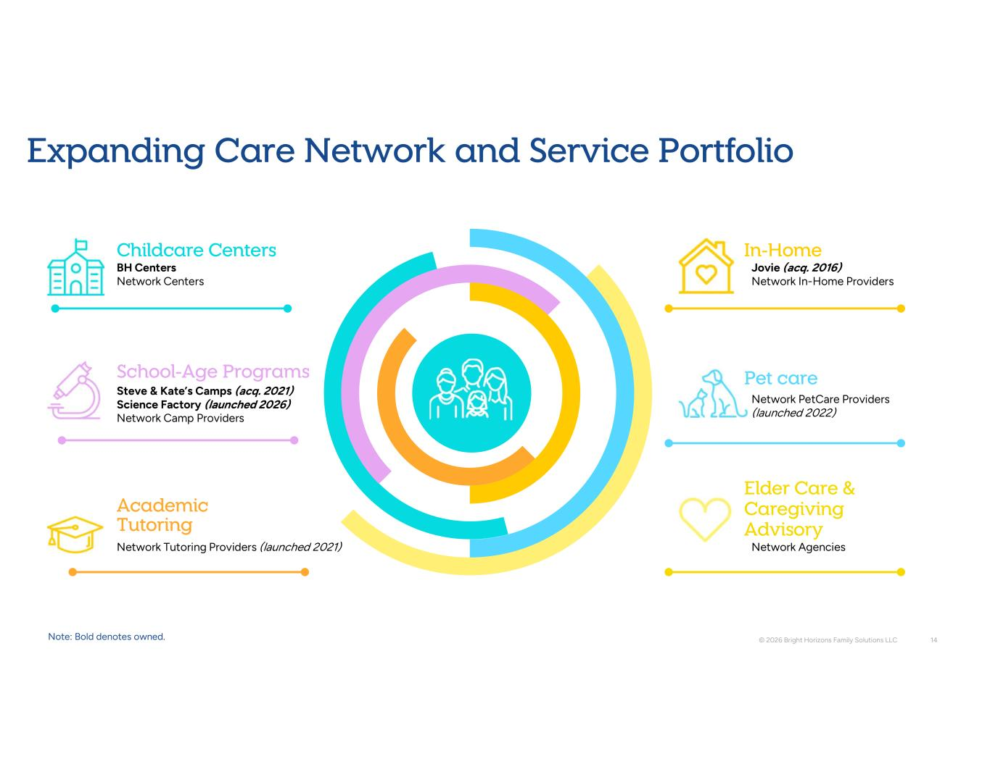
Childcare Centers School-Age Programs Academic Tutoring Pet care In-Home Elder Care & Caregiving Advisory Network Tutoring Providers (launched 2021) Steve & Kate’s Camps (acq. 2021) Science Factory (launched 2026) Network Camp Providers BH Centers Network Centers Jovie (acq. 2016) Network In-Home Providers Network PetCare Providers (launched 2022) Network Agencies © 2026 Bright Horizons Family Solutions LLC 14 Expanding Care Network and Service Portfolio Note: Bold denotes owned.

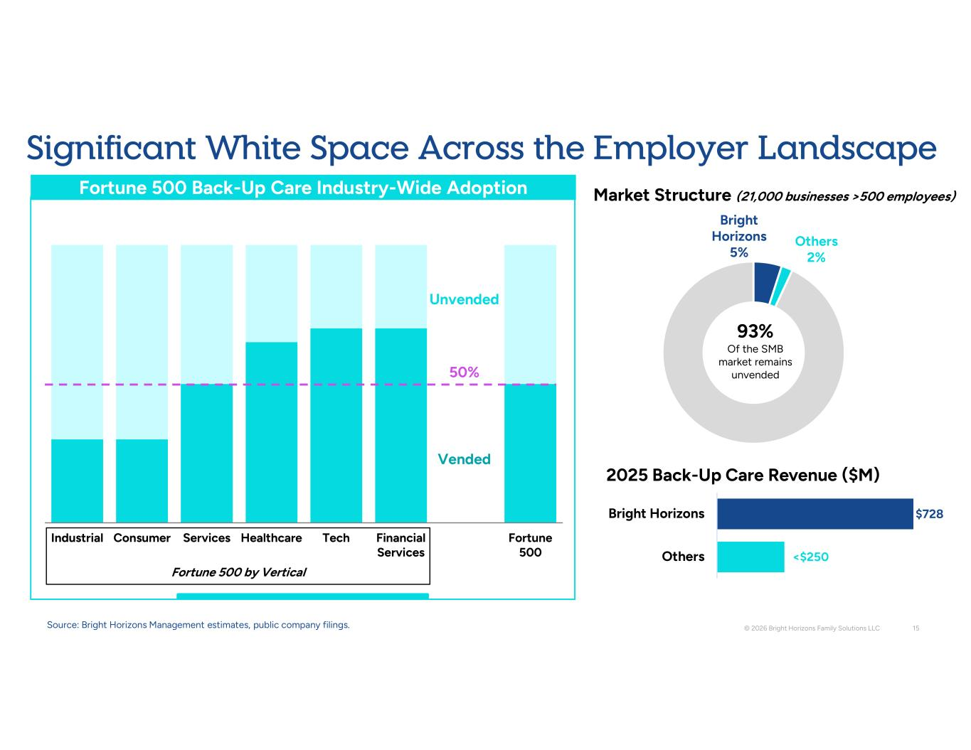
Bright Horizons 5% Others 2% Industrial Consumer Services Healthcare Tech Financial Services Fortune 500 Fortune 500 by Vertical Vended Unvended Fortune 500 Back-Up Care Industry-Wide Adoption < 250 728 Others Bright Horizons 2025 Back-Up Care Revenue ( M) Market Structure (21,000 businesses >500 employees) 93% Of the SMB market remains unvended © 2026 Bright Horizons Family Solutions LLC 15 Source: Bright Horizons Management estimates, public company filings. 50% Significant White Space Across the Employer Landscape

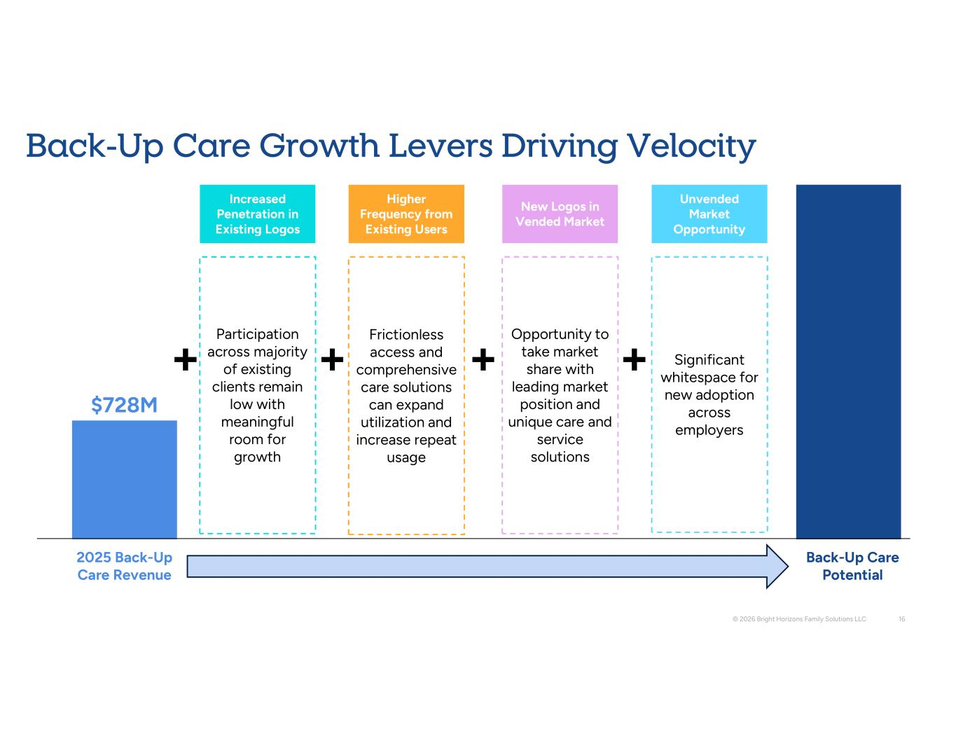
Back-Up Care Growth Levers Driving Velocity © 2026 Bright Horizons Family Solutions LLC 16 2025 Back-Up Care Revenue Back-Up Care Potential 728M Unvended Market Opportunity Significant whitespace for new adoption across employers New Logos in Vended Market Opportunity to take market share with leading market position and unique care and service solutions Increased Penetration in Existing Logos Participation across majority of existing clients remain low with meaningful room for growth Higher Frequency from Existing Users Frictionless access and comprehensive care solutions can expand utilization and increase repeat usage

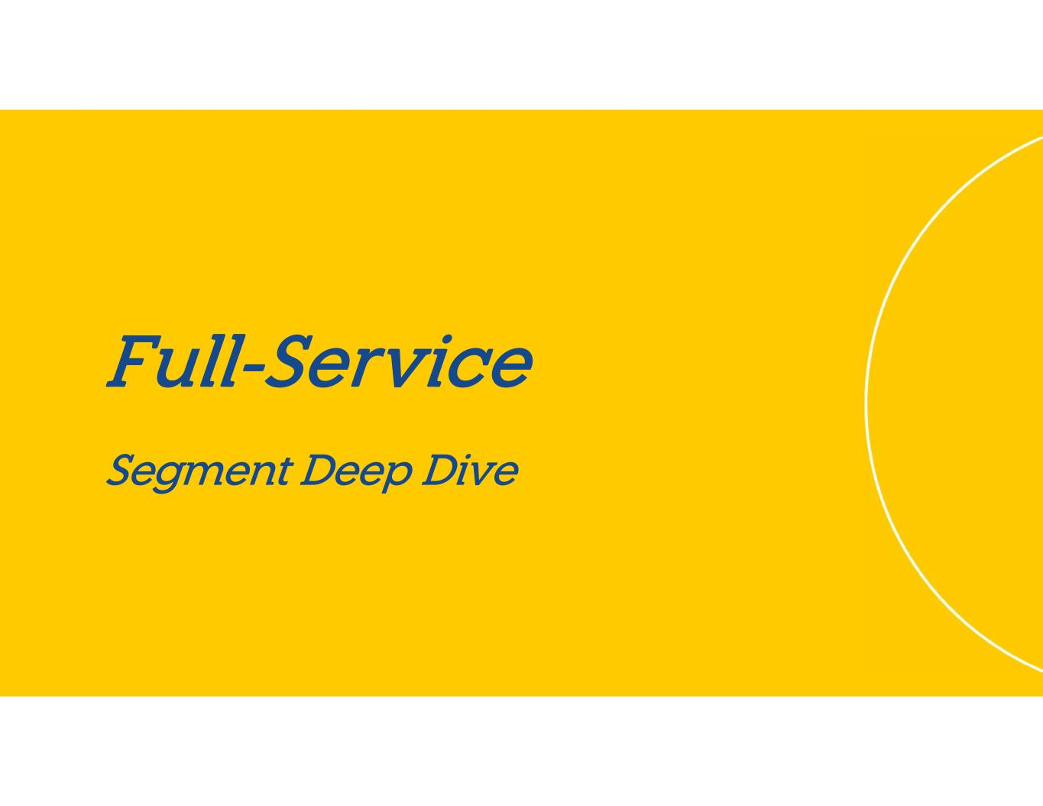
Full-Service Segment Deep Dive

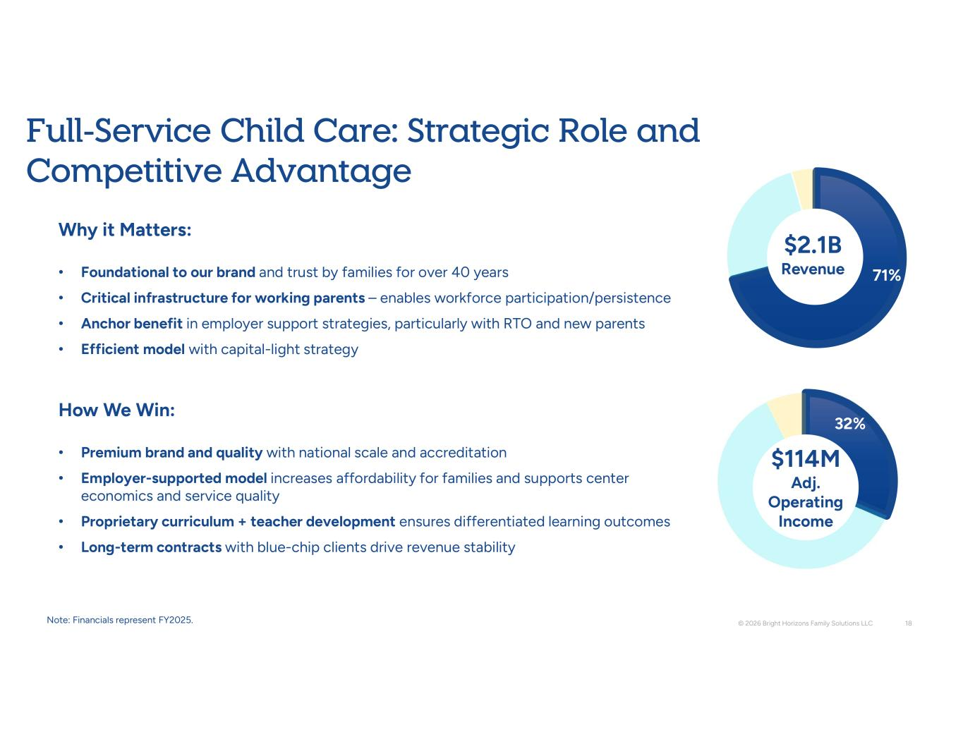
32% 71% Why it Matters: • Foundational to our brand and trust by families for over 40 years • Critical infrastructure for working parents – enables workforce participation/persistence • Anchor benefit in employer support strategies, particularly with RTO and new parents • Efficient model with capital-light strategy How We Win: • Premium brand and quality with national scale and accreditation • Employer-supported model increases affordability for families and supports center economics and service quality • Proprietary curriculum + teacher development ensures differentiated learning outcomes • Long-term contracts with blue-chip clients drive revenue stability © 2026 Bright Horizons Family Solutions LLC 18 Full-Service Child Care: Strategic Role and Competitive Advantage 2.1B Revenue 114M Adj. Operating Income Note: Financials represent FY2025.

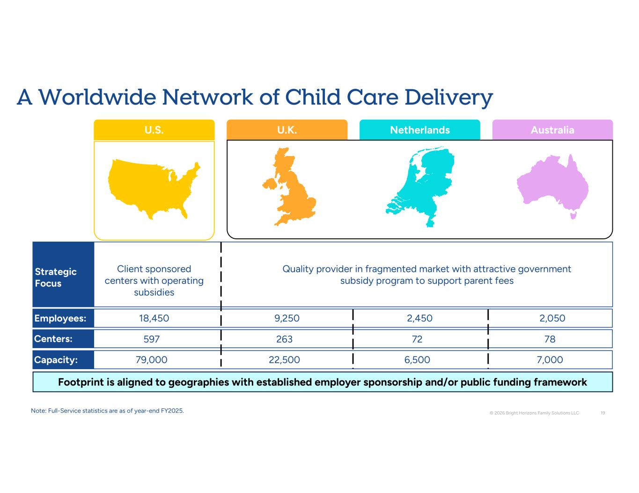
18,450 9,250 2,450 2,050 Employees: 7,000 6,500 22,500 79,000 Capacity: 78 72 263 597 Centers: © 2026 Bright Horizons Family Solutions LLC 19 U.S. U.K. Netherlands Australia Strategic Focus Client sponsored centers with operating subsidies Quality provider in fragmented market with attractive government subsidy program to support parent fees Footprint is aligned to geographies with established employer sponsorship and/or public funding framework A Worldwide Network of Child Care Delivery Note: Full-Service statistics are as of year-end FY2025.

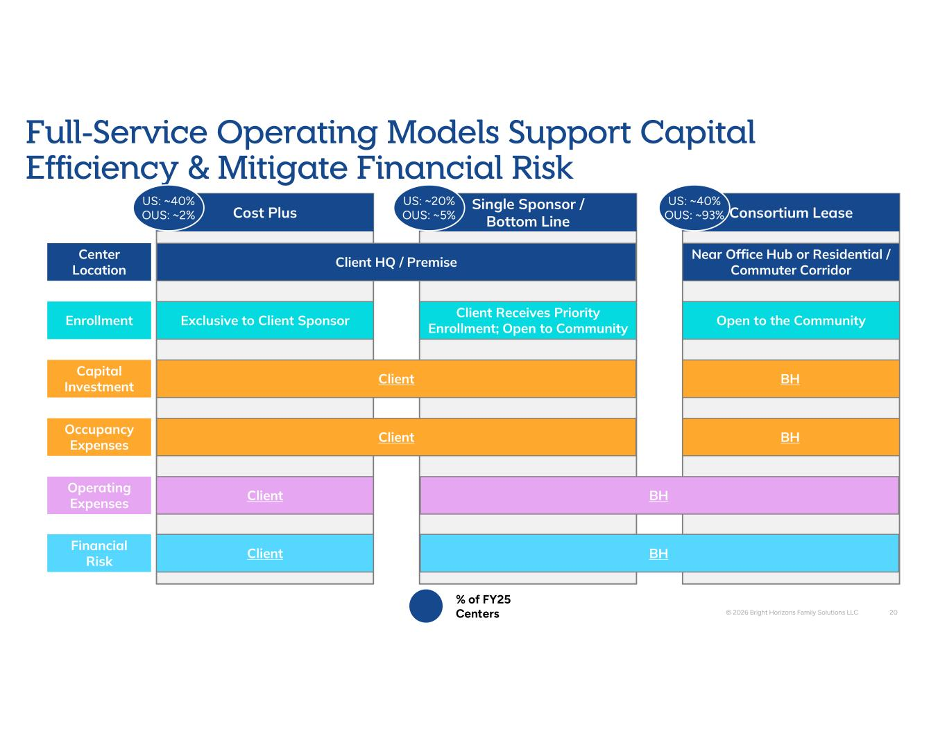
Single Sponsor / Bottom Line Client Receives Priority Enrollment; Open to Community Capital Investment Occupancy Expenses Operating Expenses Financial Risk Enrollment Center Location Consortium Lease Near Office Hub or Residential / Commuter Corridor Open to the Community BH BH BH Cost Plus Exclusive to Client Sponsor Client Client BH Client HQ / Premise Client Client © 2026 Bright Horizons Family Solutions LLC 20 Full-Service Operating Models Support Capital Efficiency & Mitigate Financial Risk % of FY25 Centers US: ~40% OUS: ~2% US: ~20% OUS: ~5% US: ~40% OUS: ~93%

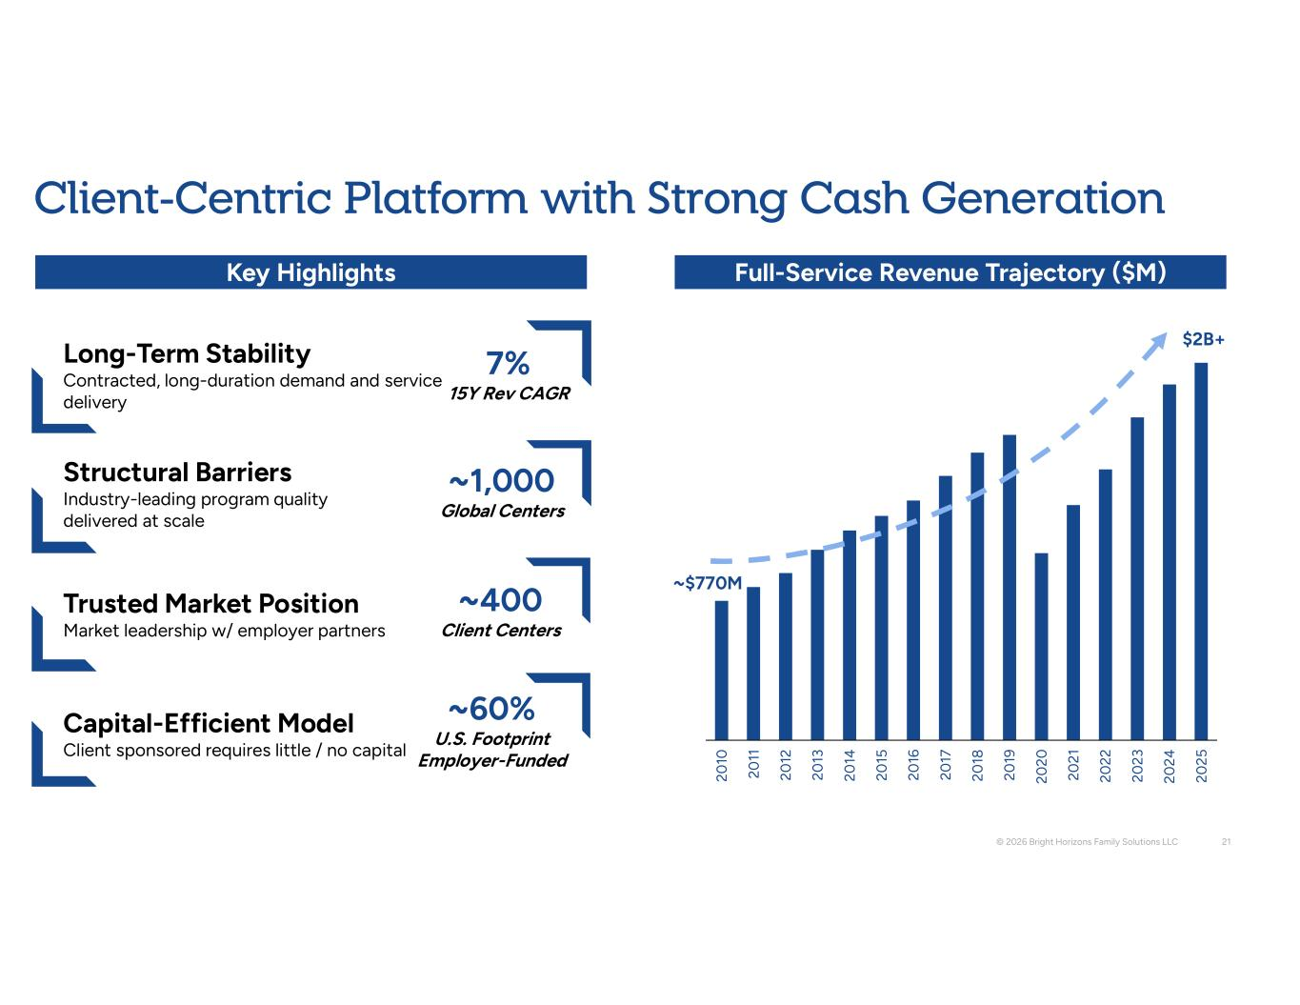
20 10 20 11 20 12 20 13 20 14 20 15 20 16 20 17 20 18 20 19 20 20 20 21 20 22 20 23 20 24 20 25 2B+ ~ 770M © 2026 Bright Horizons Family Solutions LLC 21 Client-Centric Platform with Strong Cash Generation Full-Service Revenue Trajectory ( M) Key Highlights Long-Term Stability Contracted, long-duration demand and service delivery 7% 15Y Rev CAGR Structural Barriers Industry-leading program quality delivered at scale ~1,000 Global Centers Trusted Market Position Market leadership w/ employer partners Capital-Efficient Model Client sponsored requires little / no capital ~60% U.S. Footprint Employer-Funded ~400 Client Centers

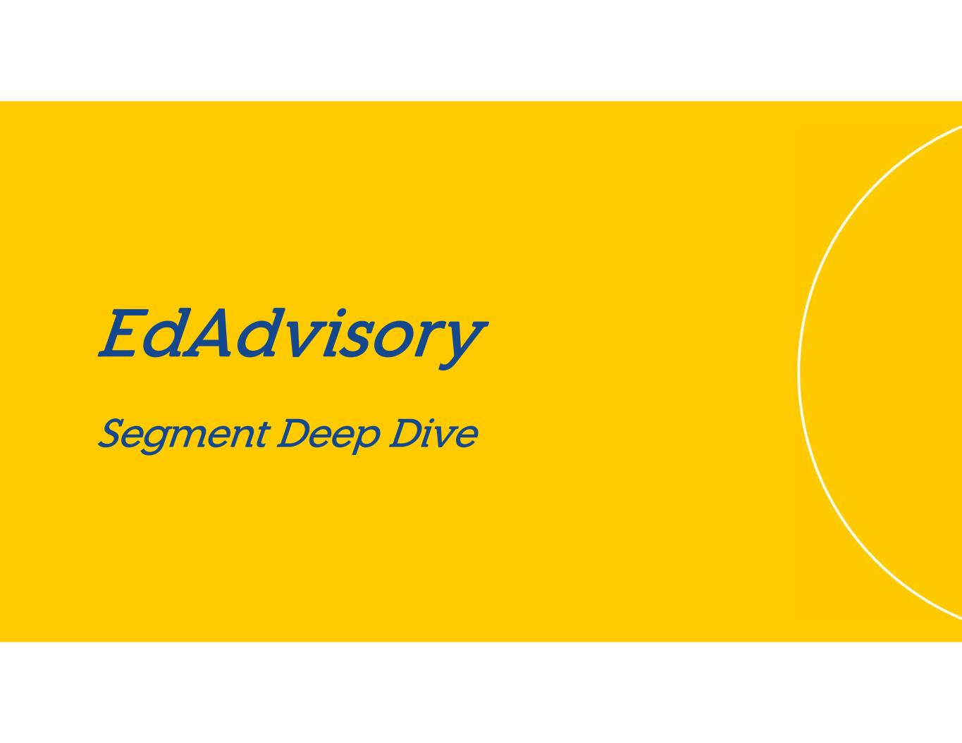
EdAdvisory Segment Deep Dive

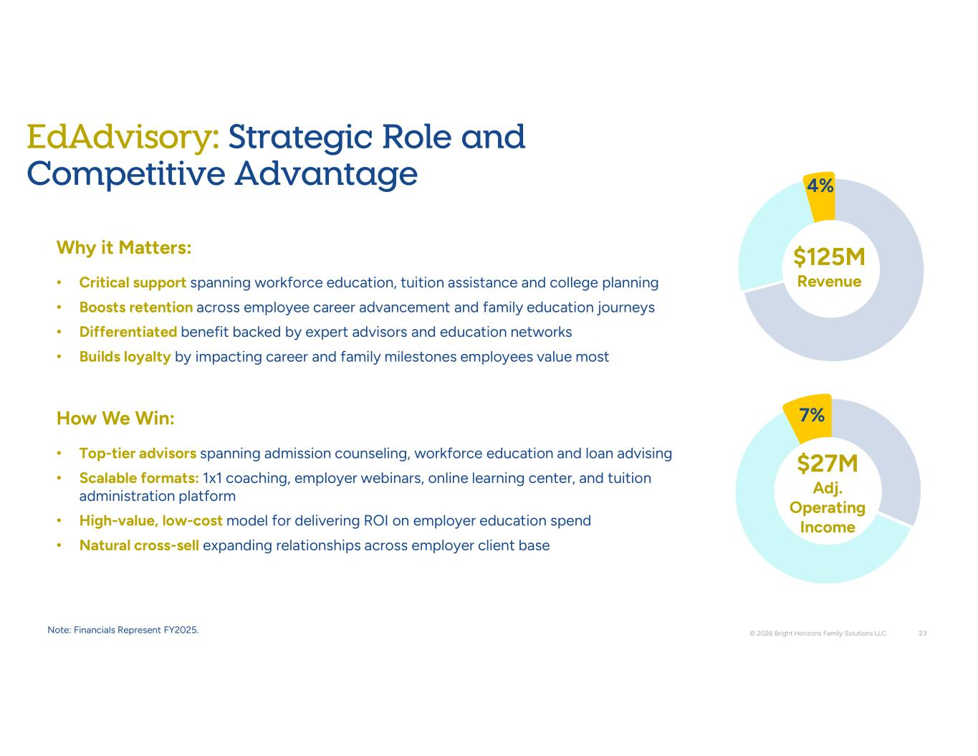
4% Why it Matters: • Critical support spanning workforce education, tuition assistance and college planning • Boosts retention across employee career advancement and family education journeys • Differentiated benefit backed by expert advisors and education networks • Builds loyalty by impacting career and family milestones employees value most How We Win: • Top-tier advisors spanning admission counseling, workforce education and loan advising • Scalable formats: 1x1 coaching, employer webinars, online learning center, and tuition administration platform • High-value, low-cost model for delivering ROI on employer education spend • Natural cross-sell expanding relationships across employer client base © 2026 Bright Horizons Family Solutions LLC 23 7% EdAdvisory: Strategic Role and Competitive Advantage 125M Revenue 27M Adj. Operating Income Note: Financials Represent FY2025.

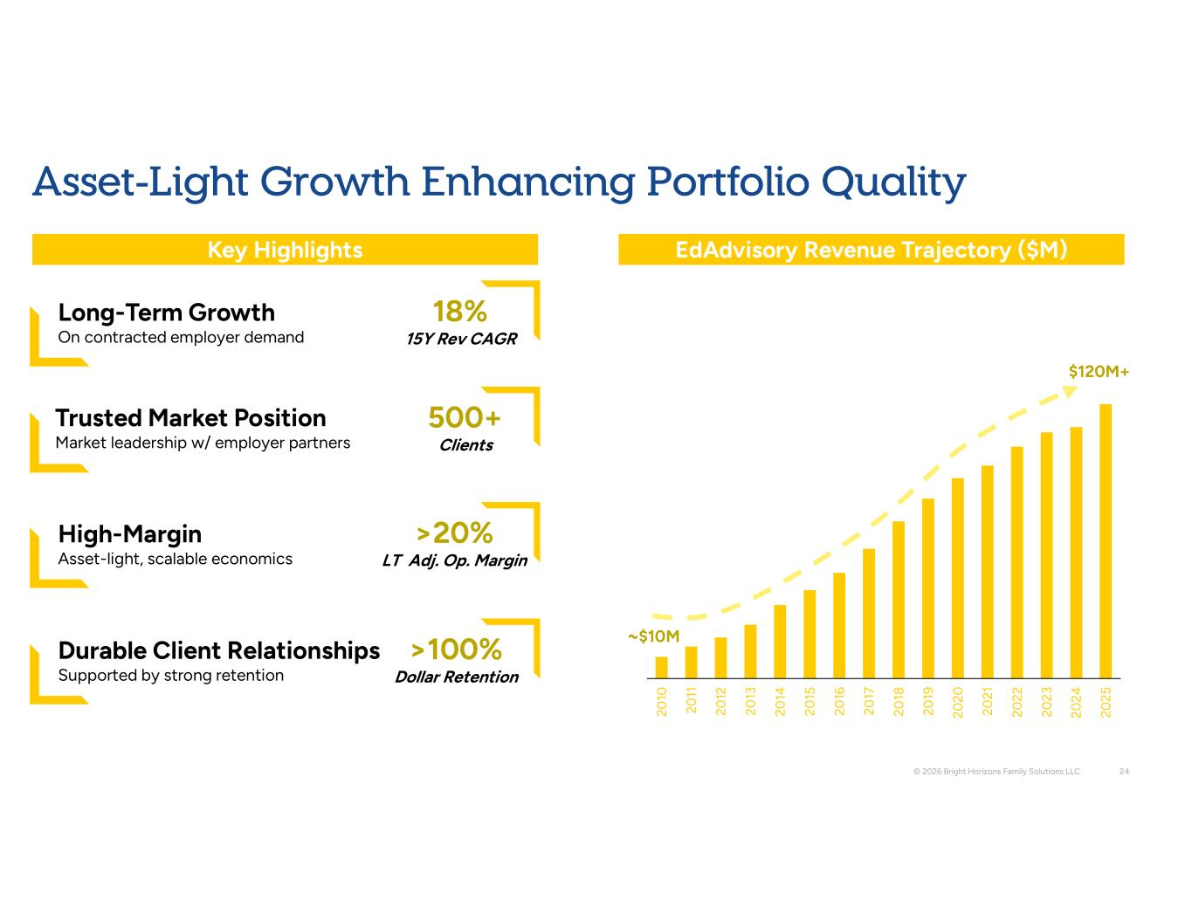
20 10 20 11 20 12 20 13 20 14 20 15 20 16 20 17 20 18 20 19 20 20 20 21 20 22 20 23 20 24 20 25 © 2026 Bright Horizons Family Solutions LLC 24 120M+ ~ 10M EdAdvisory Revenue Trajectory ( M) Key Highlights Long-Term Growth On contracted employer demand 18% 15Y Rev CAGR 500+ Clients High-Margin Asset-light, scalable economics >20% LT Adj. Op. Margin Durable Client Relationships Supported by strong retention >100% Dollar Retention Asset-Light Growth Enhancing Portfolio Quality Trusted Market Position Market leadership w/ employer partners

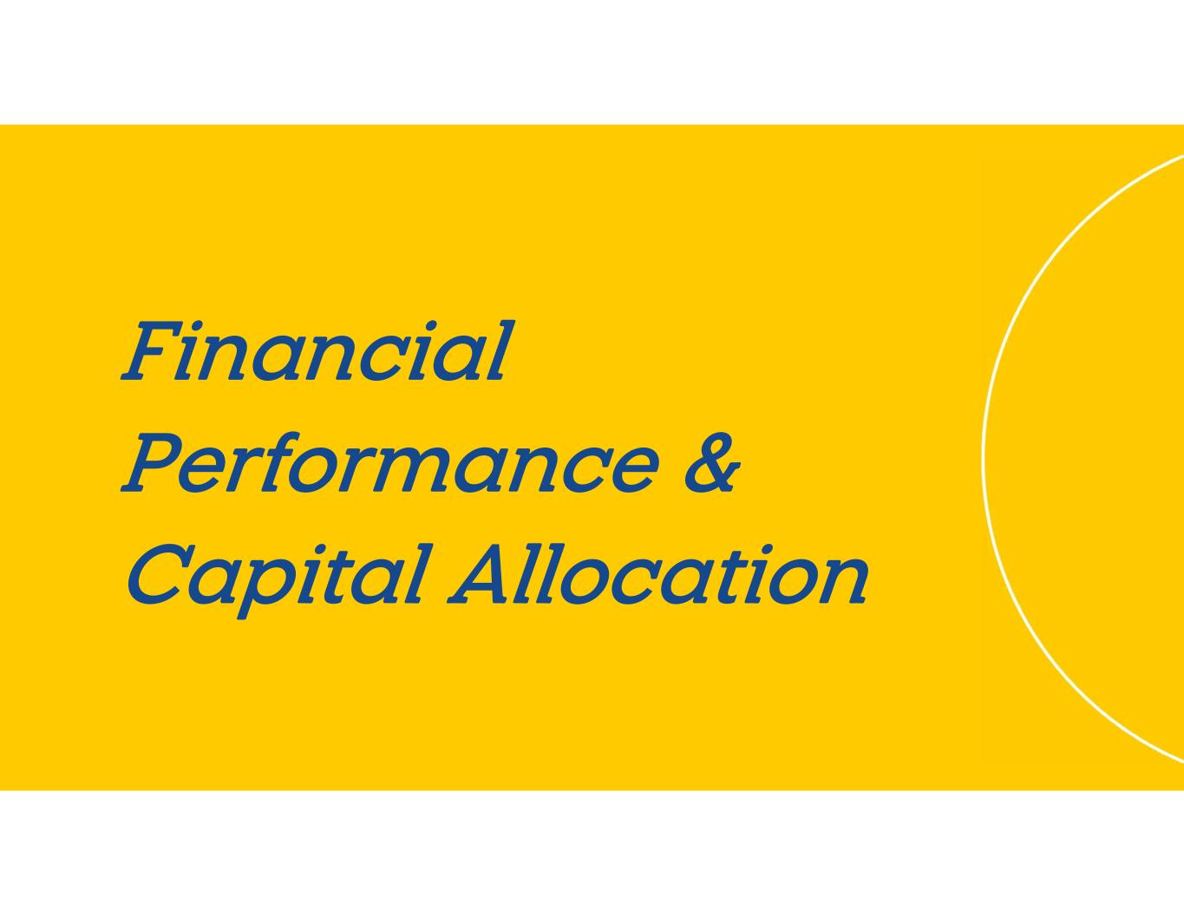
Financial Performance & Capital Allocation

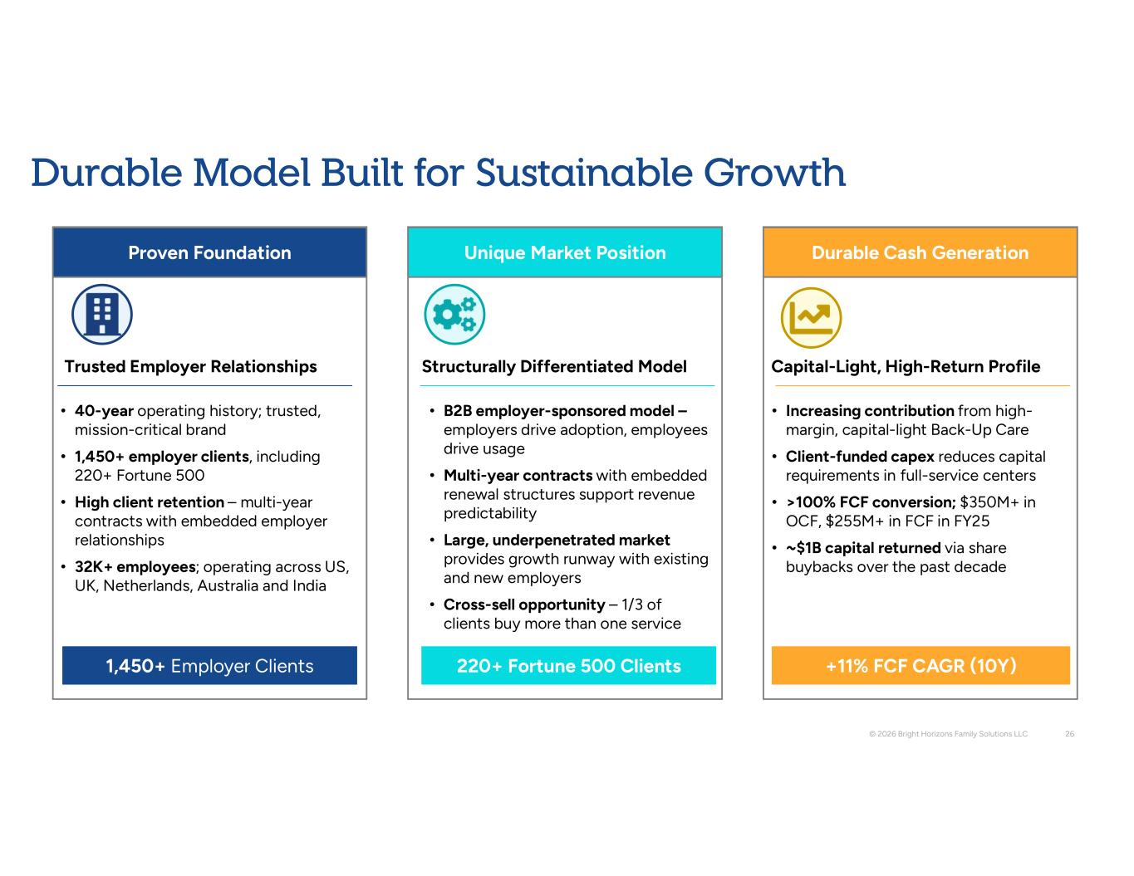
Proven Foundation Unique Market Position Durable Cash Generation • 40-year operating history; trusted, mission-critical brand • 1,450+ employer clients, including 220+ Fortune 500 • High client retention – multi-year contracts with embedded employer relationships • 32K+ employees; operating across US, UK, Netherlands, Australia and India • B2B employer-sponsored model – employers drive adoption, employees drive usage • Multi-year contracts with embedded renewal structures support revenue predictability • Large, underpenetrated market provides growth runway with existing and new employers • Cross-sell opportunity – 1/3 of clients buy more than one service • Increasing contribution from high- margin, capital-light Back-Up Care • Client-funded capex reduces capital requirements in full-service centers • >100% FCF conversion; $350M+ in OCF, $255M+ in FCF in FY25 • ~ 1B capital returned via share buybacks over the past decade Trusted Employer Relationships Structurally Differentiated Model Capital-Light, High-Return Profile 220+ Fortune 500 Clients 1,450+ Employer Clients +11% FCF CAGR (10Y) © 2026 Bright Horizons Family Solutions LLC 26 Durable Model Built for Sustainable Growth

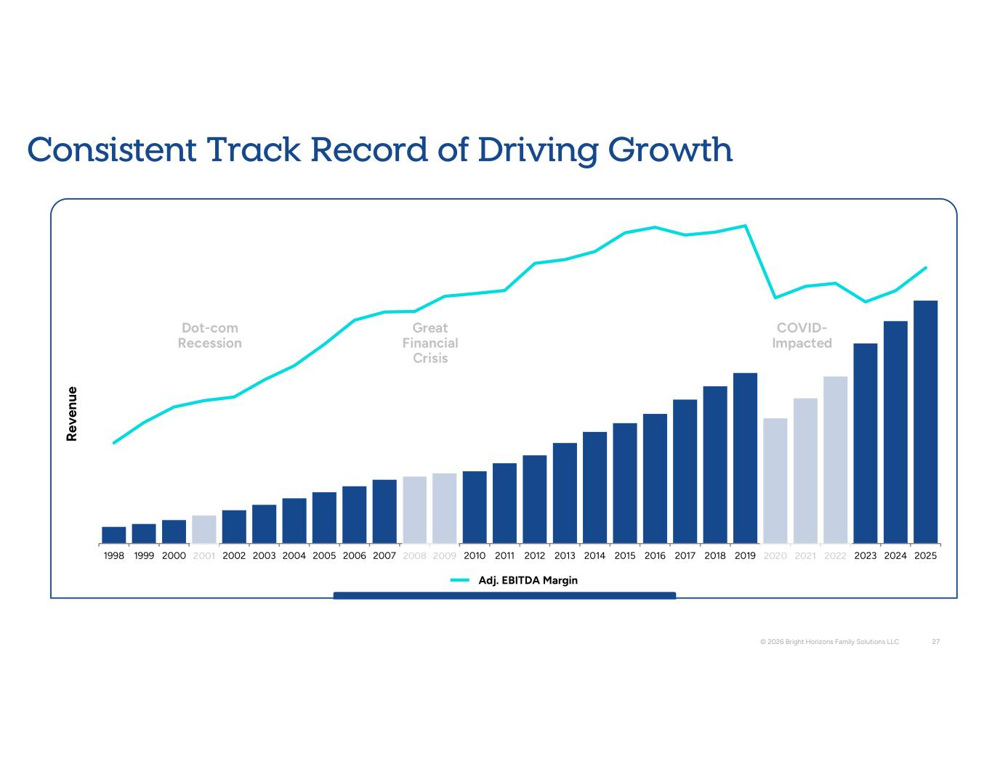
1998 1999 2000 2001 2002 2003 2004 2005 2006 2007 2008 2009 2010 2011 2012 2013 2014 2015 2016 2017 2018 2019 2020 2021 2022 2023 2024 2025 Consistent Track Record of Driving Growth R ev en ue Adj. EBITDA Margin © 2026 Bright Horizons Family Solutions LLC 27 COVID- Impacted Great Financial Crisis Dot-com Recession

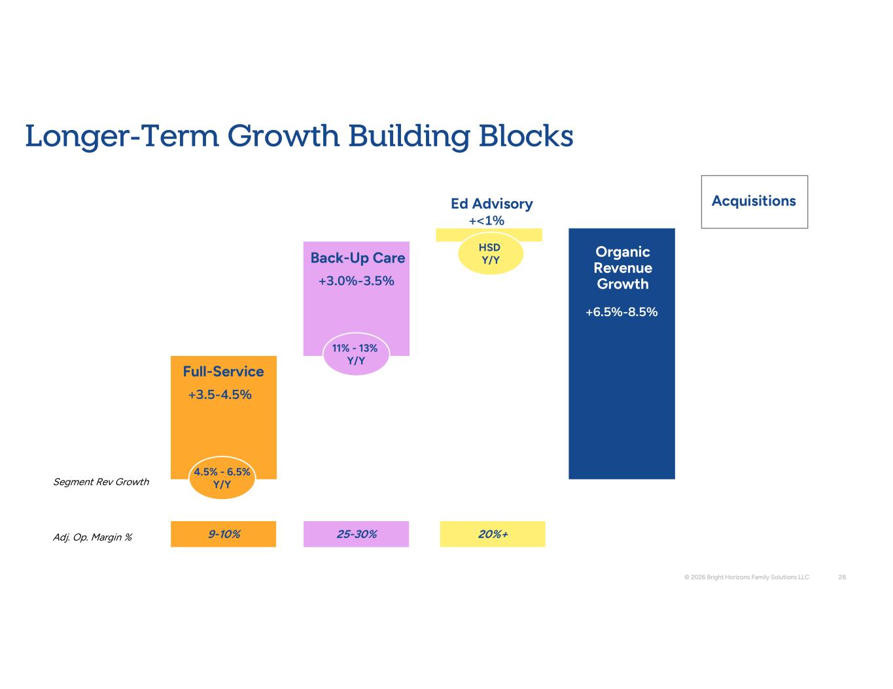
Longer-Term Growth Building Blocks Full-Service Back-Up Care Ed Advisory Acquisitions +6.5%-8.5% +3.0%-3.5% +3.5-4.5% Organic Revenue Growth © 2026 Bright Horizons Family Solutions LLC 28 4.5% - 6.5% Y/Y 11% - 13% Y/Y +<1% HSD Y/Y 9-10% 25-30% 20%+ Adj. Op. Margin % Segment Rev Growth

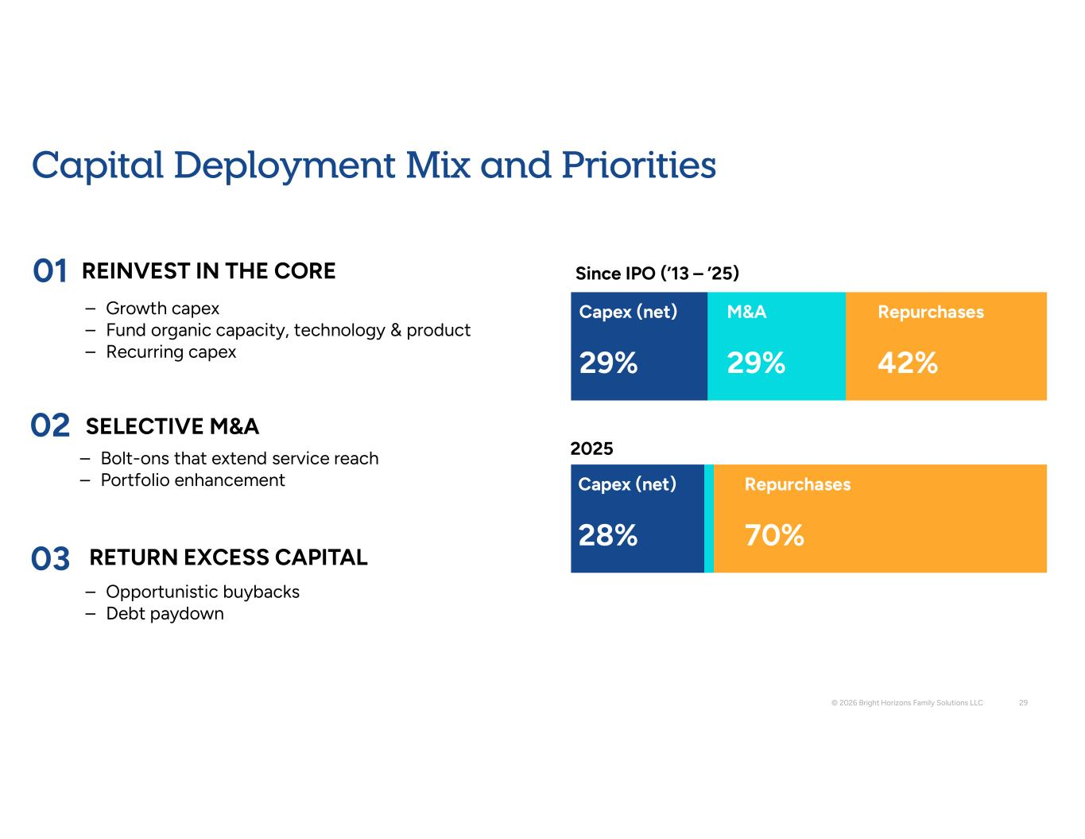
Capital Deployment Mix and Priorities © 2026 Bright Horizons Family Solutions LLC 29 29% 29% 42% Capex (net) M&A Repurchases 29% 29% 42% Capex (net) M&A Repurchases Since IPO (’13 – ’25) 2025 8 70% ( t) Repurchases 01 02 03 REINVEST IN THE CORE SELECTIVE M&A RETURN EXCESS CAPITAL – Growth capex – Fund organic capacity, technology & product – Recurring capex – Bolt-ons that extend service reach – Portfolio enhancement – Opportunistic buybacks – Debt paydown

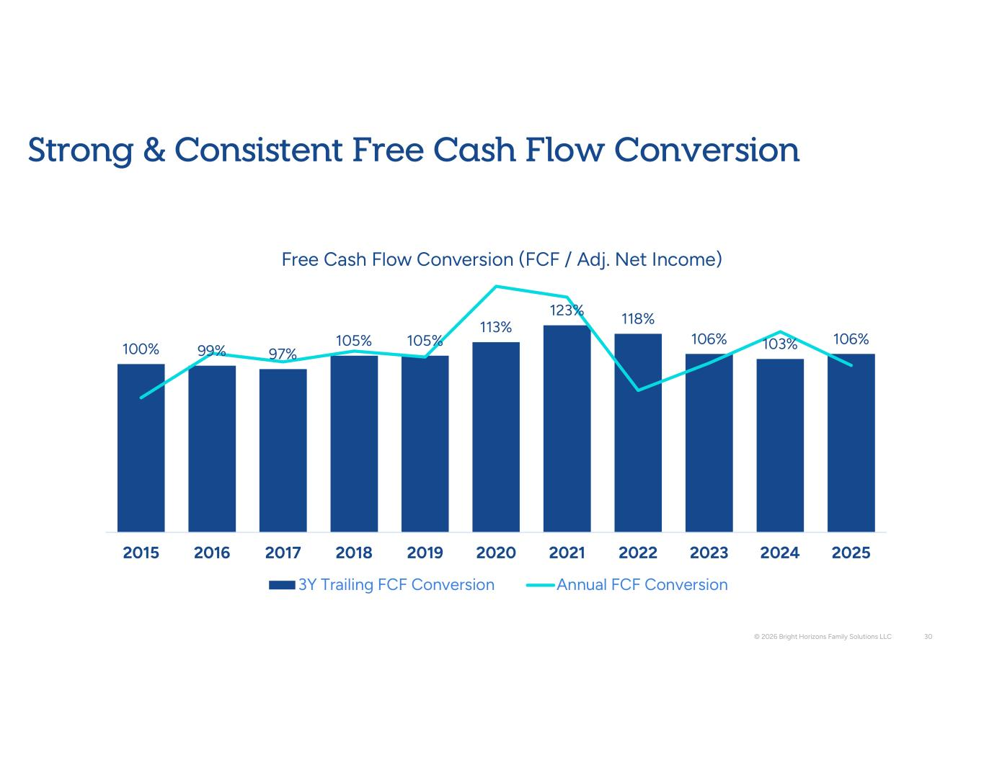
© 2026 Bright Horizons Family Solutions LLC 30 100% 99% 97% 105% 105% 113% 123% 118% 106% 103% 106% 2015 2016 2017 2018 2019 2020 2021 2022 2023 2024 2025 Free Cash Flow Conversion (FCF / Adj. Net Income) 3Y Trailing FCF Conversion Annual FCF Conversion Strong & Consistent Free Cash Flow Conversion

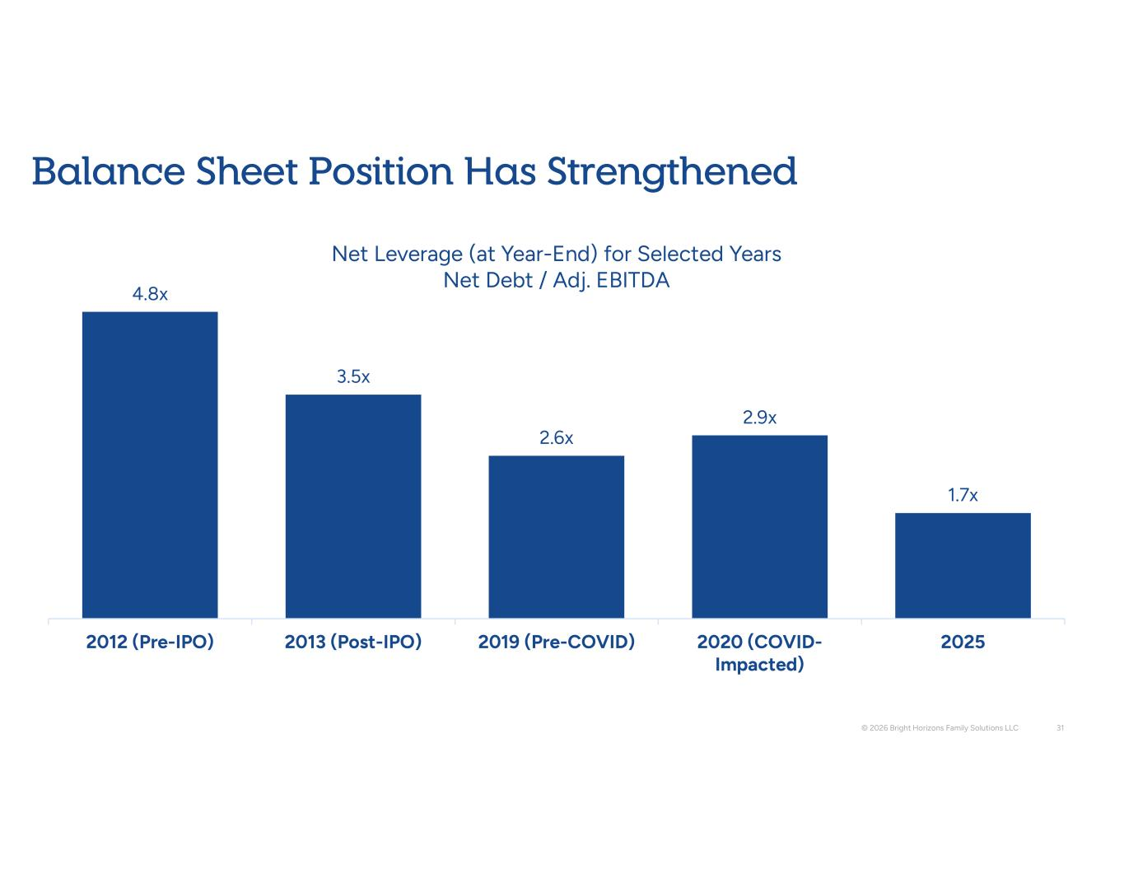
+1-2% Balance Sheet Position Has Strengthened 6-8% 4.8x 3.5x 2.6x 2.9x 1.7x 2012 (Pre-IPO) 2013 (Post-IPO) 2019 (Pre-COVID) 2020 (COVID- Impacted) 2025 Net Leverage (at Year-End) for Selected Years Net Debt / Adj. EBITDA © 2026 Bright Horizons Family Solutions LLC 31

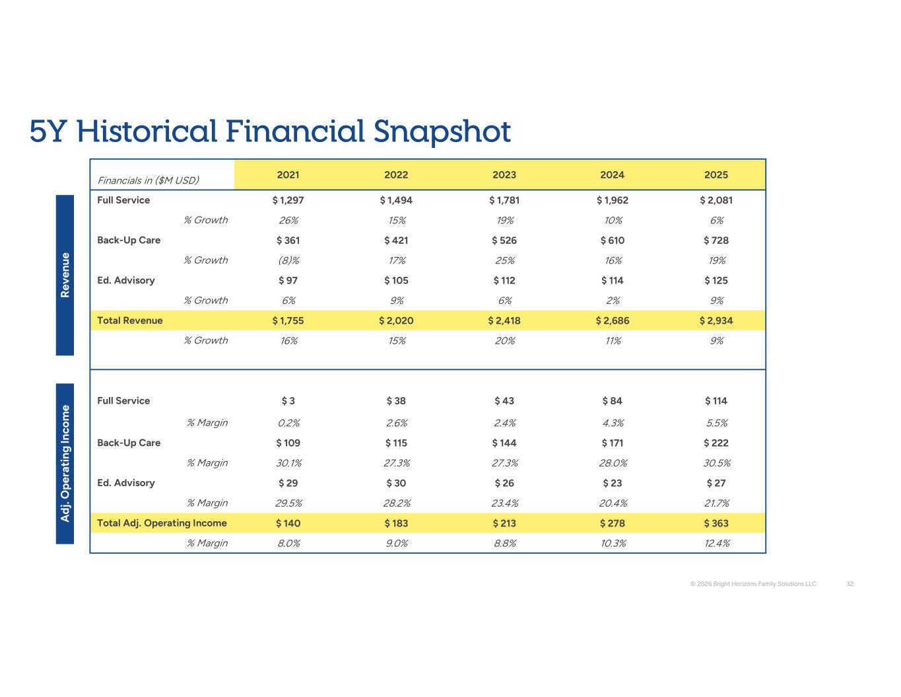
2025 2024 2023 2022 2021 Financials in ($M USD) 2,081 1,962 1,781 1,494 1,297 Full Service 6% 10% 19% 15% 26% % Growth 728 610 526 421 361 Back-Up Care 19% 16% 25% 17% (8)% % Growth 125 114 112 105 97 Ed. Advisory 9% 2% 6% 9% 6% % Growth 2,934 2,686 2,418 2,020 1,755 Total Revenue 9% 11% 20% 15% 16% % Growth 114 84 43 38 3 Full Service 5.5% 4.3% 2.4% 2.6% 0.2% % Margin 222 171 144 115 109 Back-Up Care 30.5% 28.0% 27.3% 27.3% 30.1% % Margin 27 23 26 30 29 Ed. Advisory 21.7% 20.4% 23.4% 28.2% 29.5% % Margin 363 278 213 183 140 Total Adj. Operating Income 12.4% 10.3% 8.8% 9.0% 8.0% % Margin R ev en ue A dj . O pe ra ti ng In co m e © 2026 Bright Horizons Family Solutions LLC 32 5Y Historical Financial Snapshot

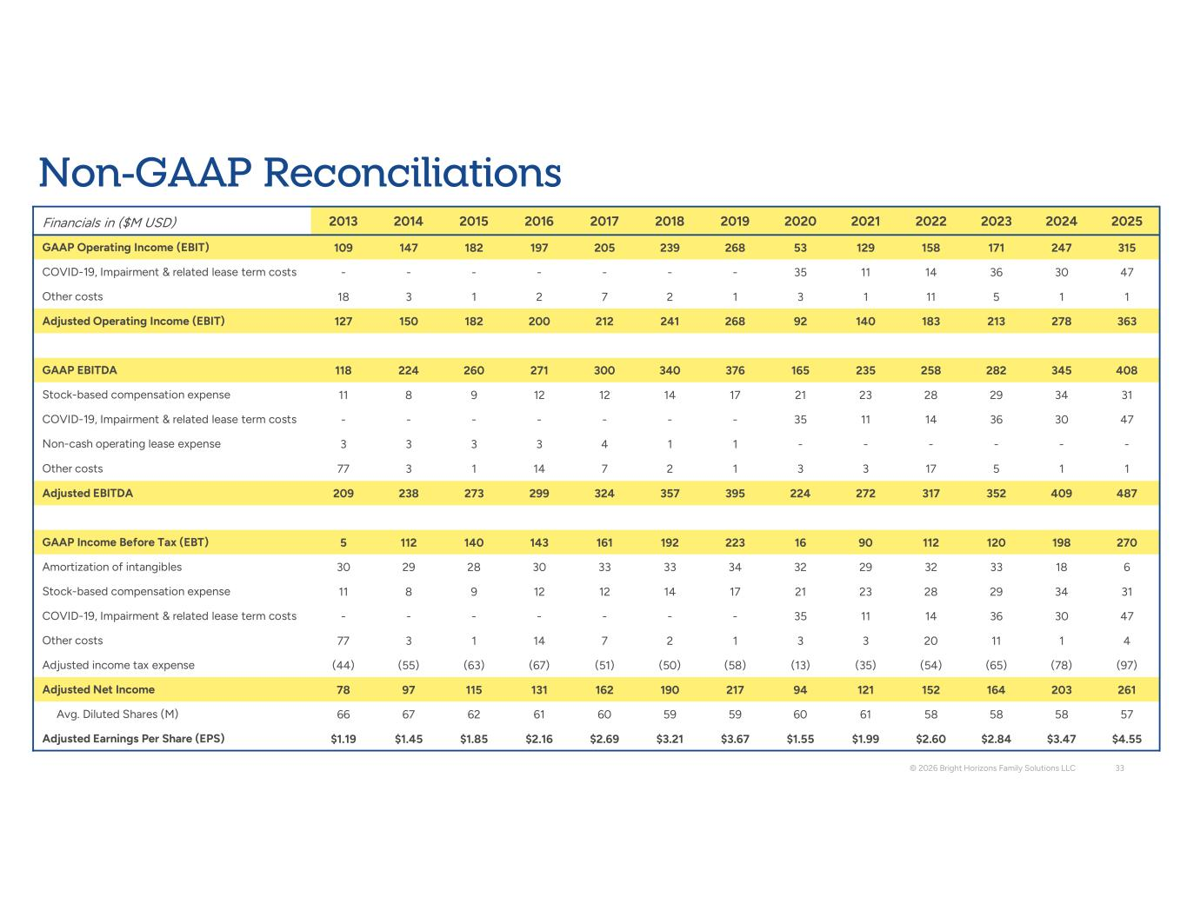
2025 2024 2023 2022 2021 2020 2019 2018 2017 2016 2015 2014 2013 Financials in ($M USD) 315 247 171 158 129 53 268 239 205 197 182 147 109 GAAP Operating Income (EBIT) 47 30 36 14 11 35 - - - - - - - COVID-19, Impairment & related lease term costs 1 1 5 11 1 3 1 2 7 2 1 3 18 Other costs 363 278 213 183 140 92 268 241 212 200 182 150 127 Adjusted Operating Income (EBIT) 408 345 282 258 235 165 376 340 300 271 260 224 118 GAAP EBITDA 31 34 29 28 23 21 17 14 12 12 9 8 11 Stock-based compensation expense 47 30 36 14 11 35 - - - - - - - COVID-19, Impairment & related lease term costs - - - - - - 1 1 4 3 3 3 3 Non-cash operating lease expense 1 1 5 17 3 3 1 2 7 14 1 3 77 Other costs 487 409 352 317 272 224 395 357 324 299 273 238 209 Adjusted EBITDA 270 198 120 112 90 16 223 192 161 143 140 112 5 GAAP Income Before Tax (EBT) 6 18 33 32 29 32 34 33 33 30 28 29 30 Amortization of intangibles 31 34 29 28 23 21 17 14 12 12 9 8 11 Stock-based compensation expense 47 30 36 14 11 35 - - - - - - - COVID-19, Impairment & related lease term costs 4 1 11 20 3 3 1 2 7 14 1 3 77 Other costs (97) (78) (65) (54) (35) (13) (58) (50) (51) (67) (63) (55) (44) Adjusted income tax expense 261 203 164 152 121 94 217 190 162 131 115 97 78 Adjusted Net Income 57 58 58 58 61 60 59 59 60 61 62 67 66 Avg. Diluted Shares (M) 4.55 3.47 2.84 2.60 1.99 1.55 3.67 3.21 2.69 2.16 1.85 1.45 1.19 Adjusted Earnings Per Share (EPS) © 2026 Bright Horizons Family Solutions LLC 33 Non-GAAP Reconciliations



